TEMPLATE For Request for Initiation of Informal Consultation
Revised February 2024
<yellow text> indicates info needed from you.
Italic orange text provides guidance and should be deleted from your letter prior to finalizing

February 5, 2024
Anne Marie Eich, Ph.D.
Assistant Regional Administrator for Protected Resources
NMFS, Alaska Region
PO Box 21668
Juneau, AK 99802

Re: Request for Initiation of Informal Consultation under section 7(a)(2) of the Endangered Species Act (ESA) for <insert permit number or project name>

Dear Dr. Eich:

The <insert Federal action agency (acronym)> proposes to <carry out/authorize/fund> the proposed project as described below. We request initiation of informal consultation under section 7(a)(2) of the Endangered Species Act for the <insert name of the project>. We have determined that the proposed activity may affect, but is not likely to adversely affect <identify ESA-listed species/critical habitat>. Our supporting analysis is provided below. We request your written concurrence if you agree with our determinations.
We determined that this project will have no effect on <insert species/critical habitat> because <insert reason>. Therefore, <insert species/critical habitat> will not be discussed further in this consultation.

Project Description
Describe the elements of the proposed action in plain language that are relevant to your analysis. Specify the area of fill, number/size/type of piles to be driven, type of equipment to be used (if relevant to the effects analysis, such as vibratory versus impact hammer), months when construction will occur, etc. Use maps and photos of the site, if available and helpful.
For Example: The Coast Guard is proposing to have a contractor remove the existing damaged Olga Strait Light 9 and replace it with three new 12 ¾-inch diameter steel pile dolphins with a 4-foot square platform (Figure 1). The estimated water depth is 18 feet.

Pile driving and removal will primarily be conducted with a vibratory hammer except for final proofing which may require the use of an impact hammer (Coast Guard 2015).

Work is expected to begin summer 2016. Pile removal will take 1-2 days followed by pile installation which will take 1-3 days (pers. comm. Brandie Theisen 2016).
This proposed project intends to <briefly explain the purpose of the project (type of information listed below)>.
We expect work to commence on <insert anticipated starting date for work>, and extend through <anticipated completion date with a buffer if practicable to prevent the need for reinitiation of consultation due to weather delays or equipment difficulties>.
Describe all activities to be carried out, the follow outlines the type of information NMFS needs for the consultation for each type of activity.
- If pile driving, include the following information:
  - Number, diameter and type of piles
  - Installation/removal method
  - Type of equipment proposed (vibratory, impact, or down the hole drilling etc.)
  - Type of substrate and bathymetry (and any other site specific characteristics available)
  - Daily and overall duration of pile driving operations.
  - Provide the sound source level and the transmission loss used to determine appropriate thresholds for species in the action area, generally the thresholds for level B disturbance (non-injurious harassment) are the distance from the source to the 160 dB isopleth for impulsive noise and to the 120 dB isopleth for non-impulsive noise. NMFS has provided proxy levels below for action agencies. If an action agency is using a different sound source level please provide the citation.
- If silt curtains or cofferdams will be used, describe:
  - How they will be installed
  - Size of area within the curtain or cofferdam
  - How long the structure will be present.
- If dredging, include the following information:
  - Dredge type and its sound source level
  - Volume of material to be removed
  - Authorized dimensions of channel and/or depths to be restored
  - Disposal location and estimate of number of trips
  - If maintenance is included, indicate the frequency of recurring dredging and location of disposal
  - Time of year proposed (dredging start and stop dates)
  - Duration of work (total hours or days of dredging)
- If there will be project vessels:
  - Sound source level for that vessel (or similar engine type) at anticipated operational speeds
  - Approximate size and type of vessel (i.e., deep draft, cargo, barge etc.)
  - Available information on speed
  - Travel routes and distances
  - Number of trips
  - Time window of operations
  - Amount of time each vessel will be underway
- If there will be project aircraft or drones:
  - Altitude being flown
  - Number of trips
  - Time window of operation
- If in-water or over-water structures:
  - Describe the size of the structure and how it will be constructed/installed
- If aquaculture:
  - Describe layout of gear (include figures wherever possible)
  - Size of area impacted/leased and portion of area where gear will be deployed
  - Complete description of gear including vertical and ground lines, anchoring methods
  - Species being grown/raised
  - How gear will be marked and maintained
  - Spat source
  - Seasonal installation and removal times (if applicable)
- If rip-rap or other material being placed on shoreline or bottom,
  - type of material and how it will be placed (e.g., small rocks by hand)
  - material source location
  - whether material will be placed below and/or above the waterline
  - volume of material to be placed
  - characteristics of substrate that will be covered
  - linear measure of shoreline to be armored
  - local bathymetry adjacent to site

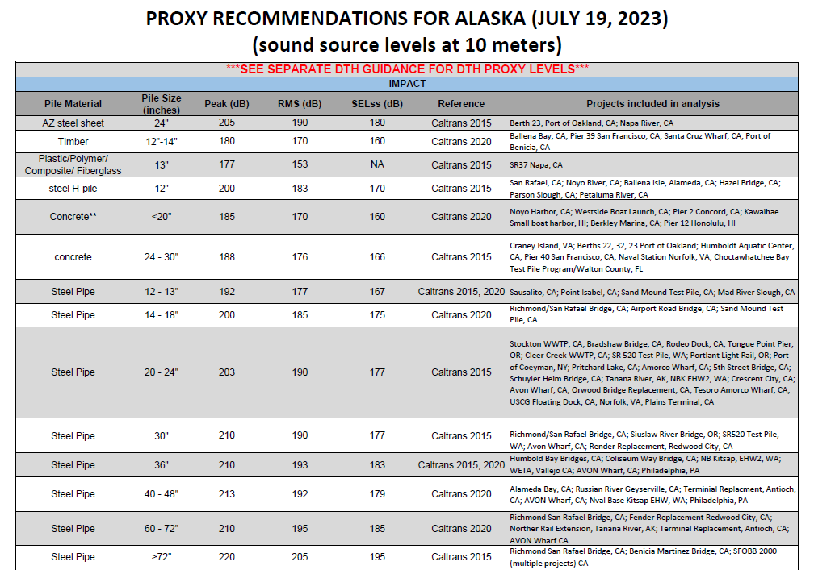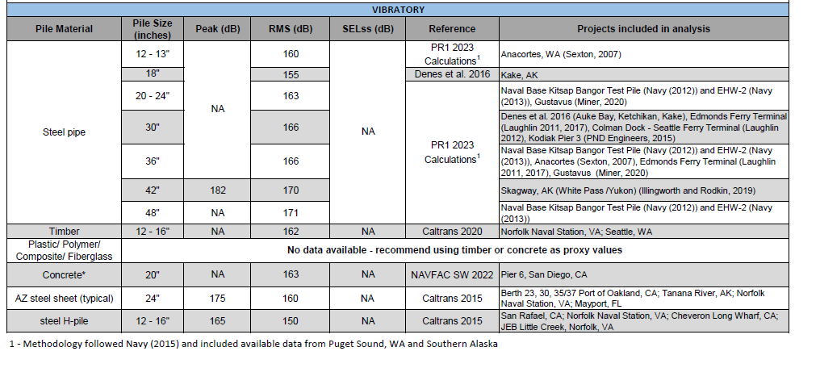
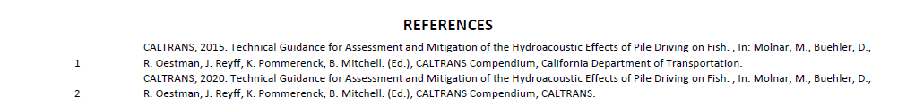

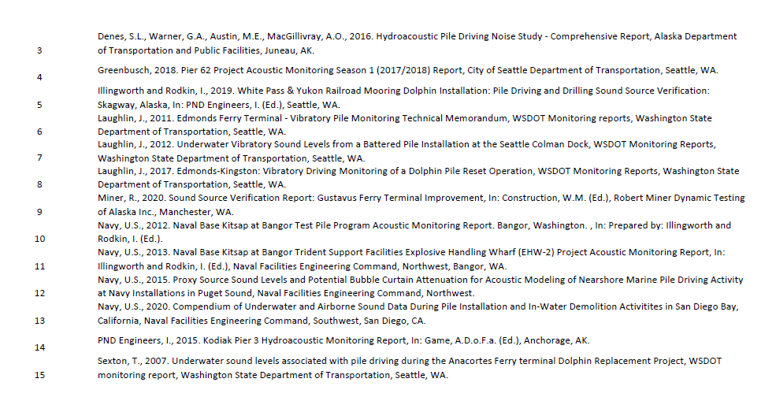

Description of the Action Area
The action area is defined in the ESA regulations (50 CFR 402.02) as the area within which all direct and indirect effects of the project will occur. The action area is distinct from and larger than the project footprint because some elements of the project may affect listed species some distance from the project footprint. The action area, therefore, extends out to a point where no measurable effects from the project are expected to occur.
For this project, the action area includes <provide a description of the geographic area where all project effects/stressors may extend, including latitude and longitude, and name of waterbody. Insert action area figure>.
For projects with acoustic impacts, the following paragraphs can be used to describe and justify the bounds of the action area.
The action area for this project is defined as the area within which project-related noise levels are ≥120 dB_{rms} re 1μPa or approaching ambient noise levels (i.e., the point where project-related sound attenuates to levels below non-anthropogenic sound). Ambient noise refers only to natural sounds like that produced by wind, waves, fish, and crustaceans. It does not include sounds from a busy port, frequent ship traffic, or any other manmade sound; natural sound plus anthropogenic sound = background sound. Received sound levels associated with <type of sound source, such as pile driving> are expected to decline to 120 dB_{rms} re 1μPa within <insert largest radius of 120 dB isopleth> of the source. To define the action area, we considered the diameter and type of piles, the pile-driving method, and empirical measurements of noise from similar projects <insert citations or other rationale e.g. modelling>.

<insert action area description and figure>

Example of what is considered the extent of the action area for construction of a new marina may include:
- Area affected by the dredging
  - Dredging area and disposal area
  - Transit route to disposal area
  - Extent of sediment/turbidity plume during dredging AND disposal
  - The anticipated distance noise may propagate from the dredging source to the 120 dB isopleth (a.k.a 300 m)
- Area affected by pile driving
  - The anticipated distance noise may propagate from the pile driving source to the 120 dB isopleth
  - Extent of sediment disturbance
- Area affected by vessel traffic
  - Number, type, and route of vessels associated with the dredging and/or marina construction to and from the project site as well as operations and functions at the project site and disposal area; new vessel traffic that may result from additional moorings/boat slips
- Area affected by the operation and maintenance of the new marina (an interdependent activity)

Mitigation Measures
The following are NMFS Alaska Region standard mitigation measures. This should be the starting point for developing mitigation measures for proposed federal actions. Additional project-specific mitigation measures will usually be needed. Adoption of all applicable mitigation measures for your project will promote a more rapid completion of the consultation

As you craft the suite of mitigation measures to be implemented as part of the proposed project, draw measures from the list below and delete non-applicable measures. When compiling your mitigation measures continue the numbering throughout your list so that each mitigation measure has a unique reference number. This allows for easy referencing of measures during consultation and beyond.

Please keep in mind that many of the mitigation measures listed use language to avoid take of ESA listed species (typically used for informal consultations). Language in these mitigation measures would need to be modified if used to describe a project undergoing formal consultation (where some take may be authorized).

To reduce needless and hazardous repetition of (possibly conflicting) mitigation measures, the following mitigation measure organizational structure was developed. Stressor-specific subsections under these headings are included as appropriate. This structure is important when an activity has multiple stressors to avoid repetition and missing an activity. If there are only one or two stressors, you may not need specific stressor subsections.

For all reporting that results from implementation of these mitigation measures, NMFS will be contacted using the contact information specified in (Table 2). In all cases, notification will reference the NMFS consultation tracking number.

General Mitigation Measures
- The project proponent will inform NMFS of impending in-water activities a minimum of one week prior to the onset of those activities (email information to akr.prd.records@noaa.gov).
- If construction activities will occur outside of the time window specified in this letter, the applicant will notify NMFS of the situation at least 60 days prior to the end of the specified time window to allow for reinitiation of consultation.
- In-water work will be conducted at the lowest points of the tidal cycle when feasible.
- Consistent with AS 46.06.080, trash will be disposed of in accordance with state law. The project proponent will ensure that all closed loops (e.g., packing straps, rings, bands, etc.) will be cut prior to disposal. In addition, the project proponent will secure all ropes, nets, and other marine mammal entanglement hazards so they cannot enter marine waters.

PSO Requirements
- At least one PSO will have either prior experience as a PSO in Alaska, or will have taken a NMFS-approved PSO or marine mammal observer training course.
- PSO training will include:
  - field identification of marine mammals and marine mammal behavior;
  - ecological information on marine mammals and specifics on the ecology and management concerns of those marine mammals;
  - ESA and Marine Mammal Protection Act (MMPA) regulations;\
  - proper equipment use;
  - methodologies in marine mammal observation and data recording and property reporting protocols; and
  - an overview of PSO roles and responsibilities.

- PSOs will be individuals independent from the project proponent and must have no other assigned tasks during monitoring periods.
- The action agency or its designated non-federal representative will provide resumes or qualifications of PSO candidates to consultation biologist and akr.prd.records@noaa.gov approval at least one week prior to in-water work. NMFS will provide a brief explanation of lack of approval in instances where an individual is not approved.
- PSOs will:
  - collectively be able to effectively observe the entirety of the shutdown zone;
  - be able to identify marine mammals and accurately record the date, time, and species, of all observed marine mammals in accordance with project protocols;
  - be able to identify listed marine mammals that may occur in the action area, at a distance equal to the outer edge of the applicable shutdown zone and determine marine mammal’s location and distance from sound source;
  - have the ability to effectively communicate orally, by radio or in person with project personnel to provide real-time information on listed marine mammals;
  - possess a copy of mitigation measures; and
  - possess data forms.
- PSOs will not scan for marine mammals for more than four hours without at least a one hour break from monitoring duties between shifts. PSOs will not perform PSO duties for more than 12 hours in a 24-hour period.

PSO Procedures
- PSOs will have the ability, authority, and obligation to order appropriate mitigation response, including shutdown, to avoid takes of listed marine mammals.
- One or more PSOs will perform PSO duties onsite throughout the authorized activity.
- Where a team of three or more PSOs are required, a lead observer or monitoring coordinator will be designated.
- For each in-water activity, PSOs will monitor all marine waters within the indicated shutdown zone radius for that activity (Table 1. Shutdown Zones for Each ActivityTable 1).
Table 1. Shutdown Zones for Each Activity
Activity | Zone Radius (m)
<Activity> | <X> meters
<Activity> | <X> meters
<Activity> | <X> meters

- PSOs will be positioned such that they will collectively be able to monitor the entirety of each activity’s shutdown zone.
- Prior to commencing any activity listed in Table 1, PSOs will scan waters within the appropriate shutdown zone and confirm no listed marine mammals are within the shutdown zone for at least 30 minutes immediately prior to initiation of the in-water activity. If one or more listed marine mammals are observed within the shutdown zone, the in-water activity will not begin until the listed marine mammals exit the shutdown zone of their own accord, or the shutdown zone has remained clear of listed marine mammals for 30 minutes immediately prior to the commencement of the activities listed in Table 1.
- The on-duty PSOs will continuously monitor the shutdown zone and adjacent waters during any of the activities listed in Table 1 for the presence of listed marine mammals.
- Activities listed in Table 1 will only take place:
  - between sunrise and sunset;
  - during conditions with a Beaufort Sea State of 4 or less; and
  - when the entire shutdown zone and adjacent waters are visible (e.g., monitoring effectiveness is not reduced due to rain, fog, snow, haze, or other environmental/atmospheric conditions).
- If visibility degrades such that PSOs can no longer ensure that the shutdown zone remains devoid of listed marine mammals during any of the activities listed in Table 1, the crew will stop activities until the entire shutdown zone is visible and the PSOs has indicated that the zone remained devoid of listed marine mammals for 30 minutes.
- The PSOs will order ongoing activities listed in Table 1 to immediately cease if one or more listed marine mammals has entered, or appears likely to enter, the shutdown zone.
- If any of the activities listed in Table 1 are shut down for less than 30 minutes due to the presence of listed marine mammals in the shutdown zone, the activities may commence when the PSOs provides assurance that listed marine mammals were observed exiting the shutdown zone. Otherwise, the activities may only commence after the PSO provides assurance that listed marine mammals have not been seen in the shutdown zone for 30 minutes (for cetaceans) or 15 minutes (for pinnipeds).
- If a listed marine mammals is observed within a shutdown zone or is otherwise harassed, harmed, injured, or disturbed, the PSO will immediately report that occurrence to NMFS using the contact information specified in Table 2.
- Prior to commencing any activity listed in Table 1, or at changes in watch, PSOs will establish a point of contact with the construction crew. The PSO will brief the point of contact as to the shutdown procedures if the PSO observes that listed marine mammals are likely to enter or enter the shutdown zone. If the point of contact goes “off shift” and delegates their duties, the point of contact must inform the PSO and brief the new point of contact.

Impact Pile Installation (pipe piles or H piles)
- If no listed marine mammals are observed within the applicable shutdown zone (see Table 1) for 30 minutes immediately prior to pile installation, soft-start procedures will be implemented immediately prior to activities. Soft-start procedures require contractors to provide an initial set of strikes at no more than half the operational power, followed by a 30-second waiting period, then two subsequent reduced-power-strike sets. A soft-start must be implemented:
  - at the start of each day’s impact pile installation;
  - any time pile installation has been shut down or delayed due to the presence of a listed marine mammal;
  - whenever pile installation has temporarily stopped (≤30 min) and PSO observation has also stopped; or
  - whenever pile installation has temporarily stopped for more than 30 min and PSO observation has also stopped.
- Following the soft-start procedure, operational impact pile installation may commence and continue provided listed marine mammals remain absent from the shutdown zone.
- Following a lapse of impact pile installation activities of more than 30 minutes, the PSO will authorize resumption of impact pile installation only after the PSO provides assurance that listed species have not been present in the shutdown zone for at least 30 minutes immediately prior to resumption of operations.

Vibratory Pipe and Sheet Pile Removal and Installation
- If no listed marine mammals are observed within the applicable shutdown zone (see Table 1) for 30 minutes immediately prior to pile removal or installation, vibratory pile removal or installation may commence. This pre-pile removal or installation observation period will take place at the start of each day’s vibratory pile removal or installation, each time pile removal or installation has been shut down or delayed due to the presence of a listed species, and following a cessation of pile driving for a period of 30 minutes or longer.
- Following a lapse of vibratory pile removal or installation activities of more than 30 minutes, the PSO will authorize resumption of vibratory pile removal or installation only after the PSO provides assurance that listed marine mammals have not been present in the shutdown zone for at least 30 minutes immediately prior to resumption of operations.

Down the Hole (DTH) drilling
- If no listed marine mammals are observed within the DTH pile driving shutdown zone for 30 minutes immediately prior to pile driving, soft-start procedures will be implemented immediately prior to activities. Soft start requires contractors to activate the drilling equipment at no more than half the operational power for several seconds, followed by a 30 second waiting period, then two subsequent reduced power start-ups. A soft start must be implemented at the start of each day’s DTH pile driving, any time pile driving has been shutdown or delayed due the presence of a listed species, and following cessation of pile driving for a period of 30 minutes or longer.
- Following this soft-start procedure, operational pile driving may commence and continue provided listed marine mammals remain absent from the shutdown zone.
- Following a lapse of pile driving activities of more than 30 minutes, the PSO will authorize resumption of pile driving only after the PSO provides assurance that listed marine mammals have not been present in the shutdown zone for at least 30 minutes immediately prior to resumption of operations.
Wood Treated Pilings
The following mitigation measures were designed to avoid adverse effects to salmonids, however they may be appropriate for other listed species, especially salmonid-eating marine mammals.

Removal
- If piles located within the project area have been abandoned or are no longer in use, they will be removed or cut off at the sediment line.
- Piles slated for removal will be completely removed. removal by vibratory pulling will be attempted, and if unsuccessful, piles will be dead pulled. Should pulling of piles be unsuccessful, they will be cut off at the sediment line.
- Piles will be reused or disposed of in a manner that does not expose or affect aquatic or marine resources.

Installation
- Creosote treated wood piles will not be reused in marine or aquatic environments.
- Composition and treatment of creosote-treated wood will conform to the most current version of the Production Guide-Best Management Practices for the Use of Preserved Wood In Aquatic and Sensitive Environments issued by Western Wood Preservers Institute, Southern Pressure Treaters’ Association, Southern Forest Products Association, Wood Preservation Canada and the Creosote Council.
- Top caps will be used on creosote treated piles.
- Construction debris must be salvaged and disposed of properly and will not be allowed to enter aquatic or marine environments
- Prefabrication of overwater structures made with creosote-treated wood products will occur before the structure is placed to minimize treated debris entry into aquatic or marine environments.
- Temporary structures designed to facilitate construction of permanent structures will be composed of untreated materials.
- Creosote-treated wood piles will not be installed in anoxic sediments or areas with low dissolved oxygen concentrations.
- Treated wood products located in areas with current velocities less than 1.0 cm/sec will be coated or wrapped with non-toxic protective barriers that are maintained throughout the life of the pile.
- 0.5 inch-thick high density polyethylene wear strips will be installed down the length of each treated wooden pile to prevent abrasion by other components and by vessels.

Dredging/Screeding/Underwater Excavating Activities
- All vessels involved in dredging, screeding, and underwater excavating operations, including survey vessels, will transit at velocities ≤10 knots.
- Dredging, screeding, and underwater excavating activities will shut down whenever a listed marine mammal enters, or appears likely to enter the applicable shutdown zone (see Table 1).
- Following a lapse of dredging, screeding, and underwater excavating activities of more than 30 minutes, the PSO will authorize resumption of the activity only after the PSO provides assurance that listed marine mammals have not been present within the shutdown zone for at least 30 minutes immediately prior to resumption of operations.
- If dredged spoils are deposited at an in-water site, the site must have a current of greater than 3 knots, the vessel making the deposit must keep moving at 3 knots or more throughout disposal, and the site must be outside of Cook Inlet beluga whale critical habitat.

Intertidal Fill/Bank Stabilization and Maintenance
- Fill material will consist of rock fill that is free of fine sediments to the extent practical, or will come from on-site dredged material
- Fill material will be obtained from local sources or will be free of non-native marine and terrestrial vegetation species.
- A PSO must be present whenever sheet piles are installed and will follow mitigation measures for impact and vibratory pile driving listed above.

Project-Dedicated Vessels (vessel and crew safety should never be compromised)
- Vessel operators will:
  - maintain a watch for marine mammals at all times while underway;
  - stay at least 91 meters (100 yards) away from listed marine mammals, except that they will remain at least 460 meters (500 yards) away from endangered North Pacific right whales;
  - travel at less than 5 knots when within 274 meters (300 yards) of a whale;
  - avoid changes in direction and speed within 274 meters (300 yards) of a whale, unless doing so is necessary for maritime safety;
  - not position vessel(s) in the path of a whale, and will not cut in front of a whale in a way or at a distance that causes the whale to change direction of travel or behavior (including breathing/surfacing pattern);
  - reduce vessel speed to 10 knots or less when weather conditions reduce visibility to 1.6 kilometers (1 mile) or less.
  - adhere to the Alaska Humpback Whale Approach Regulations when vessels are transiting to and from the project site: (see 50 CFR §§ 216.18, 223.214, and 224.103(b); these regulations apply to all humpback whales). Specifically, pilot and crew will not:
    - approach, by any means, including by interception (i.e., placing a vessel in the path of an oncoming humpback whale), within 100 yards of any humpback whale:
    - cause a vessel or other object to approach within 100 yards of any humpback whale; or
    - disrupt the normal behavior or prior activity of a humpback whale by any other act or omission.
- If a whale’s course and speed are such that it will likely cross in front of a vessel that is underway, or approach within 91 meters (100 yards) of the vessel, and if maritime conditions safely allow, the engine will be put in neutral and the whale will be allowed to pass beyond the vessel, except that vessels will remain 460 meters (500 yards) from North Pacific right whales.
- Vessels will not allow lines to remain in the water unless both ends are under tension and affixed to vessels or gear.
- Project-specific barges will travel at 12 knots or less.

Vessel Transit, North Pacific Right Whales, and their Designated Critical Habitat
- Vessels will:
  - remain at least 460 meters (500 yards) from North Pacific right whales; and
  - not travel through designated North Pacific right whale critical habitat if practicable (50 CFR 226.215). If traveling through North Pacific right whale critical habitat cannot be avoided, vessels will:
    - travel through North Pacific right whale critical habitat at 5 knots or less (without a PSO on watch); or at 10 knots or less while PSOs maintain a constant watch for listed species from the bridge; and
    - maintain a log indicating the time and geographic coordinates at which vessels enter and exit North Pacific right whale critical habitat.

Vessel Transit, Western DPS Steller Sea Lions, and their Designated Critical Habitat
- Vessels will not approach within 5.5 kilometers (3 nautical miles) of rookery sites listed in 50 CFR § 224.103(d); and
- Vessels will not approach within 914 meters (3,000 feet) of any Steller sea lion haulout or rookery.

Vessel Transit and Project Noise, Cook Inlet Beluga Whales, and their Designated Critical Habitat
- Project activity noise in excess of the 120 dB threshold will not occur between the shoreline and the mean lower low water (MLLW) line in the Susitna Delta (Beluga River to the Little Susitna River; see Figure 1 below) between April 15 and November 15. To help accomplish this:
  - Project vessel(s) operating in or transiting through Cook Inlet will maintain a distance of at least 1.5 miles south of the MLLW line;
  - Operation of airguns in Cook Inlet will not occur within 10 statute miles (8.6 nautical miles, 16 km) of the MLLW line between the Beluga and Little Susitna Rivers.
- The shutdown zones Table 1 associated with each project activity will not extend into the area between the shoreline and the MLLW line. Project-specific barges will travel 12 knots or less in Cook Inlet.
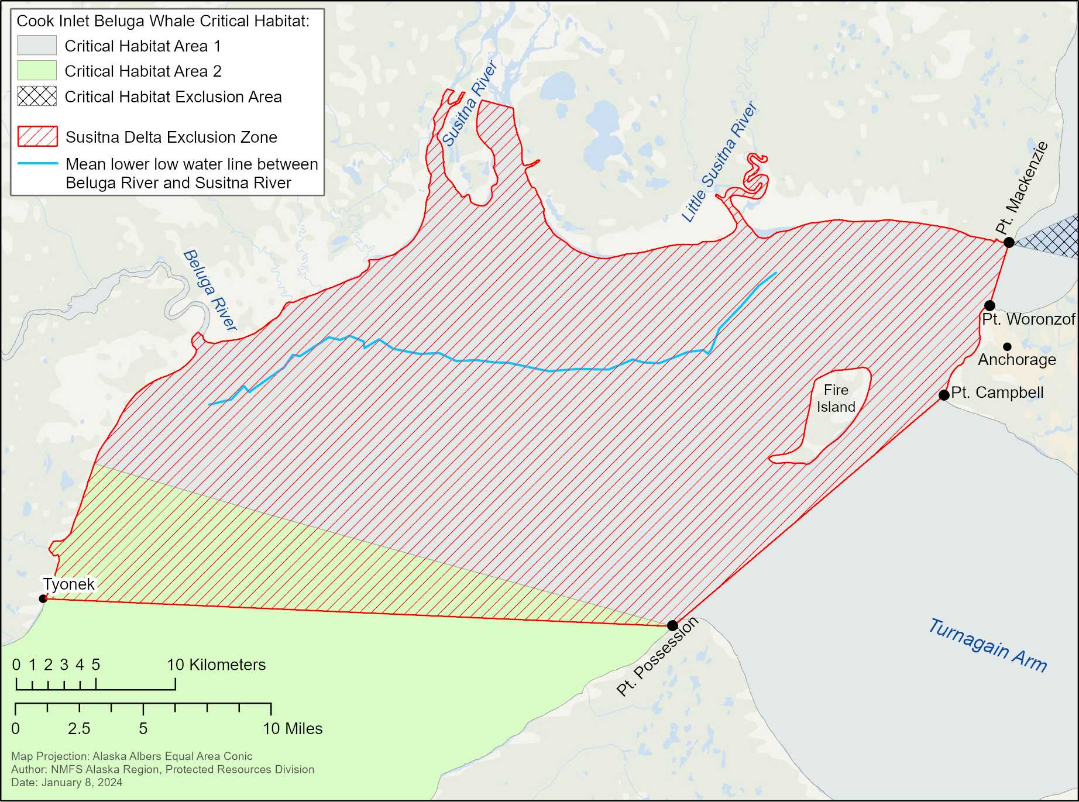
Figure 1. Susitna Delta Exclusion Zone, showing MLLW line between the Beluga and Little Susitna Rivers (red hashed area is the exclusion zone for seismic activity).

Aircraft
- Except during takeoff and landing and in emergency situations, all aircraft will transit at an altitude of at least 457 m (1,500 ft) while maintaining Federal Aviation Administration flight rules (e.g., avoidance of cloud ceiling, etc.). If flights must occur at altitudes less than 457 m (1,500 ft), aircraft will make course adjustments, as needed, to maintain at least a 457 m (1,500 ft) horizontal separation from all observed listed marine mammals.
- All aircraft will remain at least 914 m (3000 ft) from Steller sea lion haul outs and rookeries.
- Aircraft will not hover or circle over listed marine mammals.

Drones
- When operating an Unmanned Aerial Vehicle (UAV, also Unmanned Aerial System (UAS) or drone), the UAV pilot will maintain an altitude of 91 m (300 feet)AGL until a determination is made that there are no marine mammals within 91 m (300 feet) of the UAV's projected flight path. Once that determination is made, the UAV pilot may descend to no less than 30.5 m (100 feet) AGL.
- If a marine mammal is observed within 91 m (300 ft) of the UAV, the pilot will maneuver to remain at least 91 m (300 ft) lateral distance from the marine mammal.
- UAV pilots will adhere to Alaska Humpback Whale Approach Regulations when UAVs are transiting to and from the project site: (see 50 CFR §§ 216.18, 223.214, and 224.103(b)) (note: these regulations apply to all humpback whales)

Sunflower Sea Star Mitigation Measures
Please contact NMFS for up to date mitigation measures for sunflower sea stars, if they are found in your action area.

Data Collection
PSOs have the following responsibilities for data collection:
- PSOs will record observations on data forms or into electronic data sheets.
- The project proponent will ensure that PSO data will be submitted electronically in a format that can be queried such as a spreadsheet or database (i.e., digital images of data sheets are not sufficient).
- PSOs will record the following:
  - Project name, date, shift start time, shift stop time, and PSO identifier;
  - date and time of each reportable event (e.g., a listed marine mammal observation, operation shutdown, reason for operation shutdown, change in weather conditions);
  - weather parameters (e.g., percent cloud cover, percent glare, visibility) and sea state where the Beaufort Wind Force Scale will be used to determine sea state (https://www.weather.gov/mfl/beaufort);
  - species, numbers, and, if possible, sex and age class of observed listed marine mammal;
  - the predominant anthropogenic sound-producing activities occurring during each listed marine mammal observation;
  - observations of listed marine mammal behaviors and reactions to anthropogenic sounds and presence;
  - geographic coordinates of initial, closest, and last location of listed species, including distance from observer to the listed species, and minimum distance from the predominant sound-producing activity to listed species;
  - whether the presence of a listed species necessitated the implementation of mitigation measures to avoid acoustic impact (i.e., shutdown), and the duration of time that normal operations were affected by the presence of listed species.

Reporting

Unauthorized Take
- If a listed marine mammal is determined by the PSO to have been disturbed, harassed, harmed, injured, or killed (e.g., a listed marine mammal is observed entering a shutdown zone before operations can be shut down, or is injured or killed as a direct or indirect result of the action), the PSO will report the incident to NMFS within one business day, with information submitted to akr.prd.records@noaa.gov. These PSO records will include:
  - digital, queryable documents containing PSO observations and records, and digital, queryable reports.
  - the date, time, and location of each event (provide geographic coordinates);
  - description of the event;
  - number of individuals of each listed marine mammal species affected;
  - the time the animal(s) was first observed or entered the shutdown zone, and, if known, the time the animal was last seen or exited the zone, and the fate of the animal;
  - mitigation measures implemented prior to and after the animal was taken;
  - if a vessel struck a listed marine mammal, the contact information for the PSO on duty on the vessel or the contact information for the individual piloting the vessel; and
  - photographs or video footage of the animal(s), if available.

Stranded, Injured, Sick or Dead Listed Species (not associated with the project)
- If the PSO observes an injured, sick, or dead marine mammals (i.e., stranded), they will notify the Alaska Marine Mammal Stranding Hotline at 877-925-7773. The PSOs will submit photos and available data to aid NMFS in determining how to respond to the stranded animal. If possible, data submitted to NMFS in response to stranded marine mammals will include date/time, location of stranded marine mammal, species and number of stranded individuals, description of the stranded marine mammal’s condition, event type (e.g., entanglement, dead, floating), and behavior of live-stranded marine mammals.

Illegal Activities
- If the PSO observes listed marine mammals or other marine mammals being disturbed, harassed, harmed, injured, or killed (e.g., feeding or unauthorized harassment), these activities will be reported to NMFS Alaska Region Office of Law Enforcement (Table 2; 1-800-853-1964).
- Data submitted to NMFS will include date/time, location, description of the event, and any photos or videos taken.

North Pacific Right Whales
- All observations of North Pacific right whales will be reported to NMFS within 24 hours. Photographs and/or video should be taken if possible to aid in Photo ID of individual animals. Reports will include all applicable information that will be included in a final report.

Extralimital Sightings
- All observations of ESA-listed marine mammal species not considered in this consultation will be reported to NMFS within 24 hours. Photographs and/or video should be taken if possible to aid in Photo ID of individual animals. Reports will include all applicable information that would be included in a final report.

Final Report
- A final report will be submitted to NMFS within 90 calendar days of the completion of the project summarizing the data recorded by emailing it to akr.prd.records@noaa.gov. The report will summarize all in-water activities associated with the proposed action, and results of PSO monitoring conducted during the in-water activities.
- The final report for projects will include:
  - summaries of monitoring efforts, including dates and times of construction, dates and times of monitoring, dates and times and duration of shutdowns due to listed marine mammal presence;
  - dates and times of listed marine mammal observations, geographic coordinates of listed marine mammals at their closest approach to the project site, including date, water depth, species, age/size/gender (if determinable), and group sizes.
  - number of listed marine mammals observed (by species) during periods with and without project activities (and other variables that could affect detectability);
  - observed listed marine mammal behaviors and movement types versus project activity at the time of observation;
  - numbers of marine mammal observations/individuals seen versus project activity at time of observation;
  - any photos or videos taken of marine mammals;
  - digital, queryable documents containing PSO observations and records, and digital, queryable reports.

Table 2. Summary of Agency Contact Information
Reason for Contact | Contact Information
Consultation Questions & Unauthorized Take | akr.prd.section7@noaa.gov
Reports & Data Submittal | akr.prd.records@noaa.gov
Stranded, Injured, or Dead Marine Mammals | Stranding Hotline (24/7 coverage) 1-877-925-7773
Oil Spill & Hazardous Materials Response | U.S. Coast Guard National Response Center:  1-800-424-8802 and AKRNMFSSpillResponse@noaa.gov
Illegal Activities (not related to project activities; e.g., feeding, unauthorized harassment, or disturbance to marine mammals) | NMFS Office of Law Enforcement (AK Hotline):  1-800-853-1964
In the event that this contact information becomes obsolete | NMFS Anchorage Main Office: 907-271-5006 or  NMFS Juneau Main Office: 907-586-7236

Aquatic Farms and Mariculture
The permittee will implement the following mitigation measures to minimize the risk of adverse impacts to ESA-listed species from the aquatic farm:

Mariculture Infrastructure
- The number of vertical lines employed in the design of the arrays will be minimized to avoid entanglement of listed species, while providing ample strength to secure each array.
- The anchor lines and attached buoys will be removed from anchors during the non-growing season <insert dates>.
- Horizontal lines and culture gear will be removed from the water during the non-growing season <insert dates>. If an extension is needed and the array will remain in the water during part of this non-growing season, NMFS <see contacts in Table x> will be contacted at least one week prior to the start of the extension and additional monitoring may be required.
- Permittee will regularly maintain and monitor aquatic farm structures, keep lines secured, and keep lines tensioned under all tidal conditions.
- Each buoy will be marked with the aquatic farm’s ADL number (or LAS number if a temporary research site) using a method that will withstand the elements and remain legible while the buoy is deployed.
- Each site will be inspected weekly during the growing season and following any major storm event to ensure the integrity of the array.
- Moorings and anchors will be inspected at least once per growing season, and after each major storm event (i.e., sustained surface winds or frequent gusts greater than or equal to 34 knots (39 miles/hour)).

Marine Mammal Avoidance/Deterrence
- Farm staff will not interact with or feed marine mammals.
- Permittee will contact NMFS <see contacts in Table x> for recommendations of effective benign and non-lethal deterrents, if necessary, to deter predators or nuisance marine mammals.

Vessel Measures
- <include all standard vessel measures listed above>
Monitoring and Reporting (specific for aquaculture)
- Permittee will submit an annual monitoring report each year by January 30, in electronic format, to akr.prd.records@noaa.gov. The report will contain the following information:
  - A record of all visits to the aquatic farm site, including dates and times.
  - Dates the gear was deployed and retrieved from marine waters.
  - Reports of all ESA-listed species observed within 0.5 nm of the aquatic farm site. For each observation, the permittee and/or farm crew will record the date, number of individuals, approximate distance from the farm arrays, and any interactions between the animals and the vessels or array.
- Permittee will immediately report any marine mammal observed entangled or otherwise directly interacting with the aquatic farm structures to the NMFS Alaska 24-hr. Stranding Hotline: 877-925-7773.

Ice Road/Trail/Pad Mitigation Measures
Unless otherwise noted, these measures apply to both ringed and bearded seals, and ice road, ice trail, and ice pad activities. Ice road/trail/pad mitigation measures are organized into the following categories: 1) wildlife training; 2) general mitigation measures (implemented throughout the ice road/trail/pad season, which occurs generally from December through May); 3) mitigation measures to be implemented after March 1st; 4) monitoring measures, 5) communication and monitoring procedures for seal and seal structure (i.e., breathing hole or lairs) observations; 6) data collection; and 7) reporting requirements.

Wildlife Training
- Prior to initiation of sea ice road, trail, or pad construction activities, project personnel associated with ice road, trail, or pad construction, maintenance, or use (i.e., construction workers, surveyors, vehicle operators, security personnel, and the environmental team) will receive annual training on seal avoidance mitigation measures that is appropriate for the work that they will perform. The annual training for all such personnel will include reviewing applicable portions of the company’s Wildlife Interaction Plan, which include the following measures:
  - Do not approach or interact with any wildlife, it is prohibited.
  - When traveling the ice road/trail, follow directions of Security and posted signs.
  - Notify appropriate personnel if a seal is observed within 50 m (164 ft), or if a seal structure (i.e., breathing hole or lair) is observed within 150 m (~500 ft), of the centerline of the ice road/trail; or the edge of the ice pad or on the ice pad.
  - Stay in the vehicle and continue traveling at a constant speed if a seal is observed near the road/trail/pad. Do not slow down, stop, or exit the vehicle.
- In addition to reviewing the mitigation measures, wildlife training for personnel involved in ice road/trail/pad construction/maintenance or seal monitoring will include:
  - How to identify ringed seal adults and pups;
  - Seal life history;
  - Habitat and diet;
  - Presence in project area;
  - Importance of lairs, breathing holes, and basking;
  - Potential effects of disturbance; and
  - Applicable laws and regulatory requirements.

General Ice Road/Trail/Pad Mitigation Measures
- Ice road and trail mitigation measures are based on the following assumptions:
  - Ice road/trail/pad construction occurs from approximately December 1st to mid-February (or as soon as sea ice conditions allow safe access and permit such activity);
  - Operations and maintenance generally occur from approximately mid-February through mid- to late May. Ringed seals begin to establish birth lairs in late March. Therefore, NMFS is requiring that ice road/trail/pad construction be initiated no later than March 1st to reduce the potential for disturbance to ringed seal birth lairs/dens; and
  - Disturbance associated with construction prior to March 1st may deter pregnant seals from establishing birth lairs in the disturbed areas.
- Winter sea ice road/trail/pad construction and use will begin prior to March 1st of each year (typically December through mid-February), which is before most female ringed seals establish birth lairs. Initiating on-ice activities early allows ringed seals to establish breathing holes and birth lairs away from disturbed areas. Prior to establishing birth lairs, ringed seals are mobile and are expected to avoid the ice roads/trails/pads and construction activities.
The following mitigation measures will be implemented throughout the entire ice road/trail/pad season, including during construction, maintenance, active use, and decommissioning:
- Transport vehicles (passenger vehicles and trucks hauling goods) will not stop within 50 m (164 ft) of observed seals or 150 m (about 500 ft) of known seal lairs. Instead, they will continue travelling at a constant velocity.
- Ice road/trail speed limits will be 45 miles per hour (mph) or less, based on environmental, road conditions, and ice road/trail longevity considerations.
- Delineators will mark the roadway in a minimum of ¼-mile increments on both sides of the ice road to delineate the path of vehicle travel and areas of planned on-ice activities (e.g., emergency response exercises). Delineators will mark one side of an ice trail a minimum of every ¼ mile. Delineators may also be used to mark the centerline of the roadway.
- Corners of rig mats, steel plates, and other materials used to bridge sections of hazardous ice will be clearly marked or mapped using GPS coordinates of the locations.
- Any seal structures (i.e., breathing holes and lairs) observed will be avoided by a minimum of 150 m (about 500 ft) during ice testing and new road/trail/pad construction and their locations will be reported and physically marked, as described in the Communication and Monitoring Procedures for Seal and Seal Structure Observations section (below).
- Personnel will be instructed that approaching or interacting with seals is prohibited.
- If a seal is observed within 50 m (164 ft) or if a seal structure (i.e., breathing hole or lair) is detected within 150 m (about 500 ft) of the centerline of an ice road or trail, or within 50 m (164 ft) of the ice pad edge or on the ice pad, the project proponent will be informed of the observation, who will then carry out the notification protocol and implement the monitoring procedures described in Communication and Monitoring Procedures for Seal and Seal Structure Observations (below):
  - The location of the seal or seal structure will be physically marked (e.g., at its position along the axis of the ice road/trail) by placing a readily visible marker (e.g., pole and flag) within 15 m (50 ft) of the edge of the ice road/trail/pad, while maintaining a distance of at least 15 m (50 ft) from the seal/seal structure.
  - Construction, maintenance, or decommissioning work will not occur within 50 m (164 ft) of the seal, but may proceed as soon as the seal, of its own accord, moves farther than 50 m distance away from the activities or has not been observed within that area for at least 24 hours. Transport vehicles may continue their route within the designated road/trail if they can do so without stopping.
  - During the period in which a seal structure is periodically monitored as described in the Communication and Monitoring Procedures for Seal and Seal Structure Observations section (below), maintenance work will proceed in a manner that minimizes impacts or disturbance to the area.
Ice Road/Trail/Pad Mitigation Measures After March 1st
- After March 1st and continuing until decommissioning of ice roads/trails/pads is completed, on-ice activities can occur anywhere on sea ice where water depth is less than 3 m (10 ft) (i.e., habitat less suitable for ringed seal lairs and breathing holes). However, after March 1st on those sections of the ice roads/trails/pads where water depth is greater than 3 m (10 ft), all activities will occur within the boundaries of the driving lane/ice pad or shoulder area of the ice road/trail/pad and other previously disturbed areas (e.g., spill and emergency response areas, snow push areas), as long as personnel safety is ensured.
- Ice road/trail/pad construction and maintenance activities will remain 50 m (164 ft) from a seal and 150 m (about 500 ft) from a known seal structure (i.e., breathing holes and lairs) except under emergency conditions when blading or snow blowing is necessary. If snow blowing must occur within 50 m (164 ft) of a seal or 150 m (about 500 ft) of a seal structure, the snow will first be pushed so that it can subsequently be blown downwind of the animal or seal structure. On those sections of the ice roads/trails/pads where water depth is greater than 3 m (10 ft), when safety requires a new ice trail to be constructed after March 1st, construction activities such as drilling holes in the ice to determine ice quality and thickness will be conducted only during daylight hours with good visibility. Once the new ice trail is established, tracked vehicle operation will be limited to the disturbed area when safety of personnel is ensured.

Ice Road/Trail/Pad Monitoring Measures
- The following monitoring and reporting activities will be implemented by the applicant along with the mitigation measures described in the Ice Roads/trail/Pad Mitigation Measures After March 1st and Communication and Monitoring Procedures for Seal and Seal Structure Observations sections, to avoid and minimize potential impacts to ringed seals during ice road/trail/pad construction, operation, and maintenance each year.
  - If an ice road or trail is being actively used, a dedicated observer will conduct a survey along the sea ice road/trail during daylight conditions with good visibility to observe if any ringed seals are within 150 m (about 500 ft) of the roadway corridor. These protocols will be followed:
    - Surveys will be conducted every other day during daylight hours. Survey protocol consists of driving the ice road/trail and stopping every ½ mile to observe the area within 150 m (about 500 ft) of the roadway corridor for approximately 5 minutes on each side of the corridor to check for the presence of seals.
    - Observers for ice road/trail activities need not be trained Protected Species Observers (PSOs), but they will have received the training described in the Wildlife Training section above, and understand the applicable sections of the Wildlife Management Plan. In addition, they will be capable of detecting, observing, and monitoring ringed seal presence and behaviors, and accurately and completely recording data.
    - When performing observations, observers will have no other primary duty than to watch for and report observations related to ringed seals during this survey. If the observer is driving a vehicle, then the survey will be performed when the driver stops, at periodic intervals sufficient to complete a thorough assessment of the area, given visibility conditions. If weather conditions become unsafe, the monitoring activity will be discontinued.

Communication and Monitoring Procedures for Seal and Seal Structure Observations
- If a seal is observed within 50 m (164 ft) or if a seal structure (i.e., breathing hole or lair) is observed within 150 m (about 500 ft) of the centerline of the ice road/trail; or the edge of the ice pad or on the ice pad, the location of the seal or seal structure will be reported to the Environmental Specialist or Project Manager, who will then relay the observation location information to all personnel using the ice road. In addition, the personnel responsible for wildlife interaction management will be notified following protocols described in each company’s specific Wildlife Interaction Plan (see also Reporting for Ice Road/Trail/Pad Mitigation Measures). The following monitoring procedures will also be followed:
  - As soon as practicable after the initial seal observation, the Environmental Specialist or designated person will observe the seal for approximately 15 minutes to document the animal’s location relative to the road/trail/pad.
  - All work that is occurring when the seal is observed and the behavior of the seal during this observation period will be documented until the animal moves more than 50 m (164 ft) from the center of the road/trail, or more than 50 m (164 ft) from the edge of the ice pad, or is no longer observed. If the seal remains in the area after the 15-minute observation period, monitoring will continue every six hours during daylight conditions.
  - Monitoring of a seal structure by the Environmental Special or designated person will continue every six hours during daylight conditions on the day of the initial observation to determine whether a seal is present. Monitoring will consist of observing the structure from a distance of at least 150 m (about 500 ft) for approximately 15 minutes each time. After the first 24 hours, monitoring for the seal will occur every other day the ice road/trail/pad is being used unless it is determined the structure is not actively being used (i.e., a seal is not observed at that location during monitoring for 10 consecutive monitoring sessions). During this monitoring period, maintenance work will proceed in a manner that minimizes impacts or disturbance to the area.

Data Collection for Ice Road/Trail/Pad Mitigation Measures
- The Environmental Specialist, or designated person, will record the following information during survey efforts and observation events:
  - The date and start/stop time for each survey including effort in total number of hours of observation. This will include a summary of environmental conditions, such as visibility, that can affect seal or seal structure (i.e., breathing holes and lairs detection;
  - Date and time of each observation event ( e.g., initial observation of a seal or seal structure) and subsequent monitoring;
  - Number of animals per observation event; and number of adults/juveniles/pups per observation event;
  - Behaviors of seals during each observation event;
  - Geographic coordinates of the observed animals or structure (breathing hole or lair), with the position recorded by using the most precise coordinates practicable (coordinates will be recorded in decimal degrees, or similar standard, and defined coordinate system); and
  - For observation events, mitigation measures implemented to minimize impacts.

Reporting for Ice Road/Trail/Pad Mitigation Measures
- The applicant will submit an annual monitoring report after the end of the ice road/trail/pad season to summarize the activities during ice road/trail/pad construction, maintenance, use, and de-commissioning that occurred that year. Records associated with seal/seal structure (i.e., breathing holes or lairs) observations and monitoring will be transmitted to NMFS by August 31 of the year of ice road trail/pad decommissioning. This report will be submitted with the measures specified in the Data Collection for Ice Road/Trail/Pad Mitigation Measures section.
- If a specific mitigation measure is implemented during ice road/trail/pad activities in association with an observed seal/seal structure (e.g., a breathing hole is monitored for seal presence), a preliminary report of the activity will be submitted to akr.prd.records@noaa.gov within 14 days after the cessation of that activity.
- Reports and data will be submitted as digital, queryable documents (data submitted as a spreadsheet or database, reports submitted in standard word processing format. See details in the Data Collection for Ice Road/Trail/Pad Mitigation Measures section).

Listed Species and Critical Habitat
Identify ESA listed species and critical habitat under NMFS jurisdiction within the action area. If critical habitat has been designated for the species but isn’t in the action area, say so and explain where critical habitat is relative to the action area. For example: “Endangered Western DPS Steller sea lions may occur in the action area. The nearest Steller sea lion critical habitat is the Gran Point haulout (over 25 miles southeast of the action area).”

Provide a brief description for each species / critical habitat. Describe the population size and biological characteristics (such as breeding, feeding, or sheltering) that are related to the effects analysis (e.g., feeding behavior is relevant if the action may affect prey, but mating behavior is not relevant if the animal mates in Hawaii). Include any available specifics about the occurrence of the species or critical habitat in or near the action area. Below are draft status of the species sections that can be used and built upon specifically for your project.

Bowhead Whale
The bowhead whale (Balaena mysticetus) was listed as endangered under the Endangered Species Conservation Act (ESCA) in 1970 (35 FR 8491, June 2, 1970 (baleen whales listing); 35 FR 18319, December 2, 1970 (bowhead whales)), and continued to be listed as endangered following passage of the ESA. The only bowhead whale stock found in U.S. waters is the Western Arctic stock. Western Arctic bowhead whales are distributed in seasonally ice-covered waters of the Arctic and near-Arctic, generally north of 60°N and south of 75°N. Critical habitat has not been designated for the bowhead whale.
The most recent estimates of abundance for this stock were made in 2019; an ice-based survey estimated 14,025 (CV = 0.228) whales (Givens et al. 2021) while an aerial survey estimated 17,175 (CV = 0.237; Ferguson et al. 2022). The population has steadily increased in abundance since the 1980s (Givens et al. 2021) and may be approaching carrying capacity (Citta et al. 2023).
In Alaska, the majority of bowhead whales migrate annually from northern Bering Sea wintering areas (December to March), through the Chukchi Sea in spring (April to May), to the Beaufort Sea, where they spend much of the summer (June through early to mid-October) before returning to Bering Sea wintering areas in fall (September through December; Citta et al. 2020). A shift after 2012–2013 shows some bowheads are remaining in southern Chukchi Sea rather than moving through the Bering Strait and into the northwestern Bering Sea for the winter (Citta et al. 2023; Szesciorka and Stafford 2023). Spring northward migration into the southern Chukchi Sea was earlier in years with less mean January–March Chukchi Sea ice area and delayed in years with greater sea ice area. As sea ice continues to decline, northward spring-time migration could shift earlier or more bowhead whales may overwinter at summer feeding grounds (Szesciorka and Stafford 2023).
Bowheads feed almost exclusively on marine invertebrates, including small to moderately sized crustaceans, such as shrimp-like euphausiids (i.e., krill) and copepods. They are continuous filter feeders engulfing a steady stream of water carrying tiny copepods, mysids, euphausiids, and other schooling plankton which are captured on their baleen plates (Werth and Sformo 2021).
NMFS categorizes bowhead whales in the low-frequency cetacean functional hearing group, with an applied frequency range between 7 Hz and 35 kHz (NMFS 2018). Inferring from their vocalizations, bowhead whales should be most sensitive to frequencies between 20 Hz-5 kHz, with maximum sensitivity between 100-500 Hz (Erbe 2002).
Additional information on bowhead whale biology and habitat is available at:
Bowhead Whale Species Description
Marine Mammal Stock Assessment Reports: Cetaceans-Large Whales

Bowhead whales in the action area
<describe for your project>

Example <The most likely time that project activities could overlap with bowhead whales is in the summer or fall when they begin their westward migration across the shelf waters of the Beaufort and Chukchi seas.> In some years this migration occurs far from the coast (Clarke et al. 2020) but in most years bowheads travel much closer to land (e.g., Brower et al. 2022). Although bowhead whales may travel relatively close to land during their spring migration when they follow open water leads through the ice (within 50 km of the Alaskan coastline (Citta et al. 2020), <it is highly unlikely that projects would occur in northwest Alaska in April and May>. Once past Point Barrow, migrating whales travel farther from shore, mostly between 80 and 250 km of the Alaskan coastline in the Beaufort Sea (Citta et al. 2020). Bowheads rarely are found inside the barrier islands that are found along the north coast. <Project dedicated vessels could overlap with habitat occupied by bowhead whales in the summer and fall.>

Bearded Seal
NMFS listed the Beringia DPS of bearded seals (Erignathus barbatus) as threatened under the ESA on February 26, 2013, primarily due to threats associated with long-term reductions in sea ice expected to occur within the foreseeable future stemming from climate change (77 FR 76739, December 28, 2012).
A reliable population estimate is not available (Muto et al. 2022). However, as discussed by Muto et al. (2022), using a limited sub-sample of spring aerial survey data collected from the U.S. portion of the Bering Sea in 2012, Conn et al. (2014) calculated a preliminary abundance estimate of 301,836 bearded seals (95 percent confidence interval: 238,195 to 371,147) in these waters.
Bearded seals are associated with moving pack ice that roduces leads and other openings in the ice, and only rarely use areas of thick, continuous shorefast ice. They use sea ice as a platform for whelping and nursing of pups, pup maturation, and molting (shedding and regrowing hair and outer skin layers), as well as for resting (Cameron et al. 2010).
In late winter and early spring, bearded seals are widely but not uniformly distributed in broken, drifting pack ice the Bering Sea (Burns 1981; Braham et al. 1984). Some bearded seals also inhabit such pack ice the Chukchi and Beaufort seas over winter and spring (MacIntyre et al. 2015; Frouin-Mouy et al. 2016; Olnes et al. 2020; Quakenbush 2020). As the ice recedes in spring, many of the bearded seals that winter in the Bering Sea migrate north through the Bering Strait (mid-April to June) and spend the summer along the ice dge in the Chukchi and Beaufort seas, though some remain in open-water areas from the Bering Sea north (Burns 1981; Olnes et al. 2020; Quakenbush 2020).
During the open-water season, some bearded seals (largely juveniles) occur in small bays, lagoons, near river mouths, and up some rivers, particularly in late summer and fall (Oceana and Kawerak 2014; Gryba et al. 2021). While adult bearded seals have rarely been seen hauled out on land in Alaska (Burns 1981; Nelson 1981), (solitary) juvenile bearded seals have been observed or documented via satellite telemetry during the open-water season hauled out on land in some areas (Oceana and Kawerak 2014; Gadamus et al. 2015; Olnes et al. 2020) .
Bearded seals feed primarily on benthic organisms including invertebrates (crabs, shrimp, clams, worms, and snails) and some fish found on or near the seafloor (in waters typically less than 200 m deep; Cameron et al. 2010). Bearded seals of the Beringia DPS primarily feed on bivalves and crustaceans, along with fishes such as sculpins, cods, and flatfishes can also be a significant component of their diet (Dehn et al. 2007; Quakenbush et al. 2011a; Crawford et al. 2015; Quakenbush et al. 2020).
Bearded seals vocalize intensively underwater in association with territorial and mating behaviors which occur in the spring (Van Parijs et al. 2003; Van Parijs and Clark 2006). NMFS defines the functional hearing range for phocids as 50 Hz to 86 kHz (NMFS 2018).
Additional information on bearded seal biology and habitat is available at:
Bearded Seal Species Description
2010 Status Review
Marine Mammal Stock Assessment Report: Pinnipeds-Phocids
Bearded Seal Critical Habitat

Beringia DPS Bearded Seal Critical Habitat
Critical habitat for the Beringia DPS of bearded seals was designated May 1, 2022 (87 FR 19180; April 1, 2022). Critical habitat for the Beringia DPS of bearded seals comprises an area of marine habitat over the continental shelf in the northern Bering, Chukchi, and Beaufort seas (Figure 2).
The following physical and biological features associated with critical habitat for the Beringia DPS of bearded seals were identified as essential to the conservation of the species: 1) sea ice habitat suitable for whelping and nursing, which is defined as areas with waters of 200 meters or less in depth containing pack ice of at least 25% concentration and providing bearded seals access to those waters from the ice; 2) sea ice habitat as a platform for molting, which is defined as areas with waters 200 meters or less in depth containing pack ice of at least 15% concentration and providing bearded seals access to those waters from the ice; and 3) primary prey resources to support bearded seals: waters of 200 meters or less in depth containing benthic organisms, including epifaunal and infaunal invertebrates, and demersal fishes.

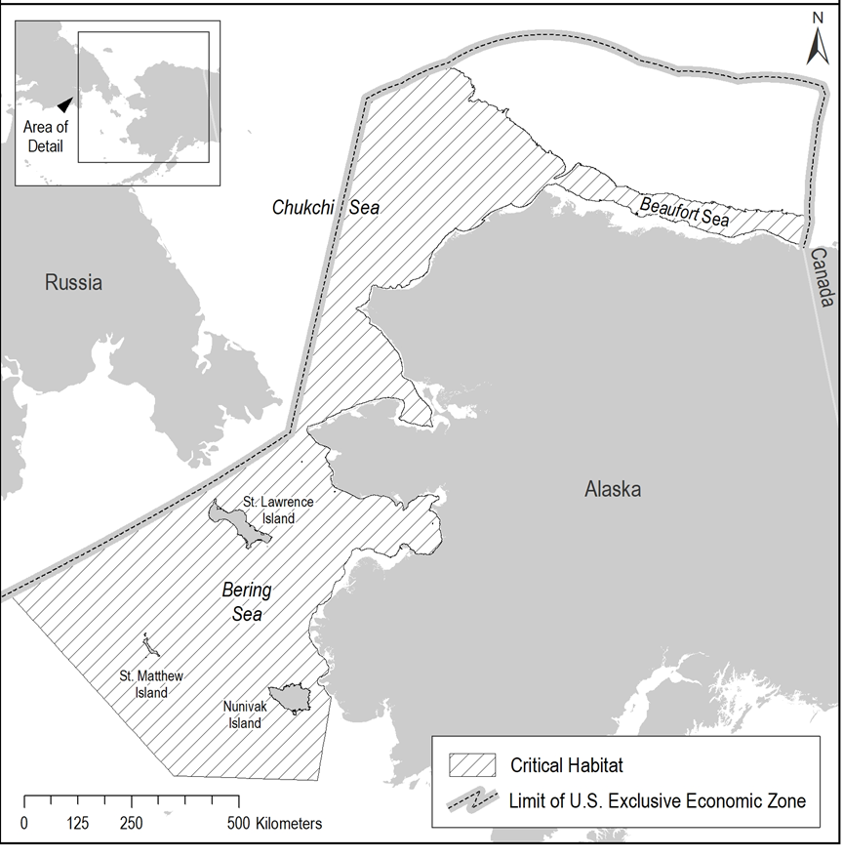

Figure 2. Critical habitat for the Beringia DPS of bearded seals.

Bearded seals and critical habitat in the action area
<describe for your project>

Arctic Ringed Seal
The Arctic subspecies of ringed (Pusa hispida hispida) was listed as threatened under the ESA on February 26, 2013, primarily due to threats associated with long-term reductions in sea ice and on-ice snow expected to occur within the foreseeable future (77 FR 76706, December 28, 2012).
A reliable population estimate is not available (Muto et al. 2022). However, as discussed by Muto et al. (2022), using a limited sub-sample of aerial survey data collected from the U.S. portion off the Bering Sea in 2012, Conn et al. (2014) calculated an abundance estimate of 174,418 ringed seals (95 percent confidence interval: 141,588 to 201,090) in these waters. Because this estimate did not account for availability bias or include ringed seals in shorefast ice, the actual number of ringed seals in the U.S. portion of the Bering Sea is likely much higher (Muto et al. 2022). Kelly et al. (2010) estimated the total population of ringed seals in the Chukchi and Beaufort seas in Alaska to be at least 300,000 based on estimates from aerial surveys conducted in the late 1990s and 2000 (Frost et al. 2004; Bengtson et al. 2005), which they noted is likely an underestimate since the Beaufort Sea surveys were limited to within 40 km of shore.
Arctic ringed seals are highly associated with sea ice, which they use as a platform for whelping and nursing pups in spring, molting in spring to early summer, and resting throughout the year (Kelly et al. 2010)(Figure 3). Ringed seals are able to open and maintain breathing holes in the ice, which allows them to inhabit heavily ice-covered areas. At some breathing holes with sufficient snow cover, ringed seals excavate lairs in snowdrifts on the surface of the ice within which they rest and give birth to and nurse pups (Smith and Stirling 1975; Williams et al. 2006) (Hauser et al. 2021). These subnivean lairs are important to pup survival because they provide shelter from extreme cold and concealment from predators (Lukin and Potelov 1978; Smith et al. 1991; Smith and Lydersen 1991; Stirling and Smith 2004).
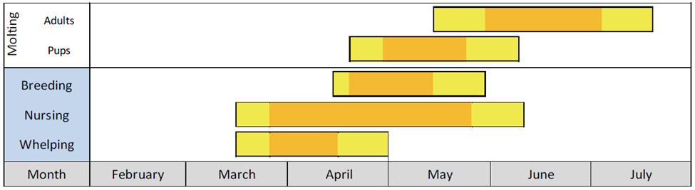
Figure 3. Approximate annual timing of Arctic ringed seal reproduction and molting. Yellow bars indicate the “normal” range over which each event is reported to occur and orange bars indicate the “peak” timing of each event (Kelly et al. 2010).
During winter and spring, ringed seals are found throughout the Chukchi and Beaufort seas (Frost 1985; Kelly 1988), and aerial surveys indicate that they use nearly the entire ice field over the Bering Sea shelf (Braham et al. 1984; Lindsay et al. 2021) Most ringed seals that winter in the Bering and southern Chukchi seas are thought to migrate north in spring as the ice recedes (Frost 1985). Tracking data indicate that ringed seals extensively use the continental shelf waters of the Chukchi and Beaufort seas during the open-water season, and some seals make excursions into deep waters north of the shelf break (Crawford et al. 2012; Quakenbush et al. 2019; Quakenbush et al. 2020; Von Duyke et al. 2020). Ringed seals (primarily juveniles) have also been observed near river mouths and in lagoons in some areas during the open water season, especially during fall (Oceana and Kawerak 2014; Gryba et al. 2021)².
Arctic ringed seals typically lose a significant proportion of their blubber mass in late winter to early summer and then replenish their blubber reserves during late summer or fall and into winter (Ryg et al. 1990; Young and Ferguson 2013; Quakenbush et al. 2020). Diet studies indicate that ringed seals in Alaska eat a wide variety of vertebrate and invertebrate prey species, but certain prey species, such as Arctic cod, saffron cod, shrimps, and amphipods, occupy a prominent role in their diet (Dehn et al. 2007; Quakenbush et al. 2011b; Crawford et al. 2015; Quakenbush et al. 2020).
The behavioral context of ringed seal underwater vocalizations is not well known, but they are thought to play a role in the seals’ reproductive behavior (Stirling 1983; Kelly 2022). NMFS defines the functional hearing range for phocids (seals) as 50 Hz to 86 kHz (NMFS 2018).
More information on ringed seal biology, habitat, and distribution is available at:
Ringed Seal Species Description
Marine Mammal Stock Assessment Report: Pinnipeds-Phocids
2010 Status Review
Arctic Ringed Seal Critical Habitat

Arctic Ringed Seal Critical Habitat
Critical habitat for the Arctic ringed seal was designated May 1, 2022 (87 FR 19232, April 1, 2022). Arctic ringed seal critical habitat comprises an area of marine habitat in the northern Bering, Chukchi, and Beaufort seas (Figure 4).
The following physical and biological features associated with Arctic ringed seal critical habitat were identified as essential to the conservation of the species: 1) snow-covered sea ice habitat suitable for the formation and maintenance of subnivean lairs used for sheltering pups during whelping and nursing, which is defined as waters 3 meters or more in depth (relative to mean lower low water, MLLW) containing areas of seasonal landfast (shorefast) ice or dense, stable pack ice, that have undergone deformation and contain snow drifts of sufficient depth to form and maintain birth lairs (typically at least 54 centimeters deep); 2) sea ice habitat suitable as a platform for basking and molting, which is defined as areas containing sea ice of 15% or more concentration in waters 3 m or more in depth (relative to MLLW); and 3) primary prey to support Arctic ringed seals, which are defined to be small, often schooling, fishes, in particular, Arctic cod, saffron cod, and rainbow smelt; and small crustaceans, in particular, shrimps and amphipods.
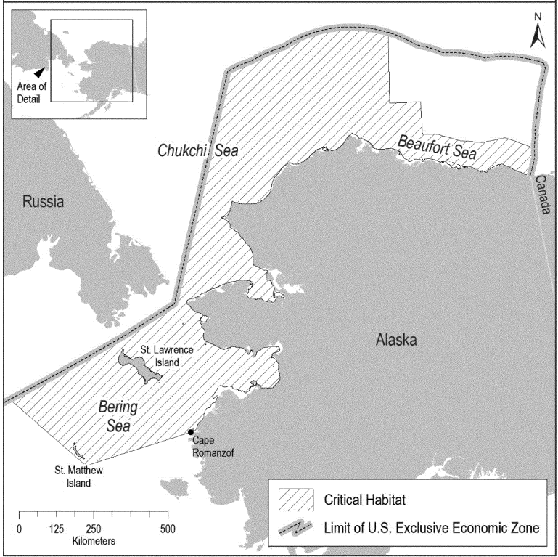
Figure 4. Ringed seal critical habitat.

Arctic ringed seals and critical habitat in the action area
<describe for your project>

Western North Pacific DPS Gray Whale
The gray whale (Eschrichtius robustus) was originally listed as endangered in 1970 (35 FR 8491, June 2, 1970 (baleen whales listing); 35 FR 18319, December 2, 1970 (gray whales)). The Eastern North Pacific (ENP) DPS stock was delisted on June 16, 1994 (59 FR31094), when it reached pre-exploitation numbers. The Western North Pacific (WNP) population of gray whales remains listed as endangered. Critical habitat has not been designated for WNP DPS gray whales. The WNP DPS gray whales are considered to be gray whales that spend all or part of their lives in the western North Pacific in the waters of Vietnam, China, Japan, Korea (Republic of Korea and/or Democratic People’s Republic of Korea), or the Russian Far East, including southern and southeastern Kamchatka but not necessarily areas north of 55°N in eastern Kamchatka (NMFS 2023). Some WNP DPS gray whales spend part of their time in U.S. waters. The population size of the WNP DPS gray whales was estimated from photo-ID data for Sakhalin and Kamchatka at 290 non-calf whales in 2016 (90 percentile intervals = 271-311; Cooke et al. 2017; Cooke 2018). The non-ESA-listed ENP DPS gray whale population is estimated at approximately 14,526 individuals (Eguchi, Lang and Weller 2023).
Gray whales travel alone or in small, unstable groups and are bottom feeders that remove infaunal invertebrate prey and sediments by suction (Oliver and Slattery 1985). WNP gray whales feed during the summer and fall in the Okhotsk Sea off northeast Sakhalin Island, Russia, and off southeastern Kamchatka in the Bering Sea (Damon-Randall 2023; NMFS 2023). The non-listed ENP population of gray whales feed mainly in the Chukchi, Beaufort, and northwestern Bering seas, with the exception of a small number of whales that summer and feed along the Pacific coast between Kodiak Island, Alaska and northern California (Carretta et al. 2022). The strong matrilineal fidelity exhibited by the whales feeding off Sakhalin Island, suggests behavioral separation of the WNP DPS from the ENP gray whales feeding in the northern Bering Sea (NMFS 2023). Therefore, we do not expect WNP DPS gray whales to be in the Alaskan waters of the Bering Sea.
In the North Pacific Ocean, the current migratory route and wintering areas of the WNP DPS of gray whales is complex and not fully understood (Weller et al. 2015; Weller et al. 2016). Studies support a trans-Pacific Ocean migration for some animals during the winter to areas off Canada, the U.S. West Coast, and Mexico. However, other animals stay in the western North Pacific Ocean and migrate south along the coast of Asia in the winter (Omura 1988; Brownell Jr, Kasuya and Weller 2007; Weller and Brownell Jr 2012; Weller et al. 2015; Weller et al. 2016). Satellite tag tracks, photo-identification, and genetic matches between Sakhalin, Kamchatka, Canada, the U.S., and Mexico have identified 60 individuals known to travel between the eastern North Pacific Ocean and western North Pacific Ocean (Martinez-Aguilar et al. 2022) (Weller et al. 2012; Mate et al. 2015; Urban R. et al. 2019) leaving open the question about the proportion of the Western North Pacific DPS of gray whales that remain in the western North Pacific Ocean year-round. The number of Western North Pacific DPS of gray whales remaining in the western North Pacific Ocean year-round is small, likely fewer than 100 individuals (Cooke 2018). The specific migration route and timing of the WNP DPS grays are unknown making it very difficult to predict when and where they might pass through the Aleutian Island chain or along the coast of Alaska.
Based on the best available information, it is expected that approximately 100% of the gray whales found in the western North Pacific Ocean feeding areas (Sakhalin, Kamchatka), wintering areas (Japan and China), and migratory corridor (Eastern Russia, North Korea, South Korea, Vietnam, and Japan) are from the Western North Pacific DPS (Damon-Randall 2023). It is expected that approximately 0.4 to 1.6% of the gray whales found in the eastern North Pacific Ocean wintering areas (Mexico) and migratory corridor (United States West Coast [Alaska, Washington, Oregon, and California], Canada, and Mexico) are from the Western North Pacific DPS (Damon-Randall 2023). Therefore, there is a low likelihood that a gray whale from the WNP DPS will be encountered in Alaskan waters along the Aleutian Islands, Gulf of Alaska, and Southeast Alaska.
No data are available regarding WNP DPS gray whale hearing and little regarding communication; but we assume that it is similar to the ENP DPS gray. Individuals produce broadband sounds within the 100 Hertz to 12 kHz range (Dahlheim, Fisher and Schempp 1984; Jones and Swartz 2009). The most common sounds encountered are on feeding and breeding grounds, where “knocks” with a source level of roughly 142 decibels have been recorded (Thomson and Richardson 1995). Gray whale rattles, clicks, chirps, squeaks, snorts, thumps, knocks, bellows, and sharp blasts at frequencies of 400 Hz to 5 kHz have been recorded in Russian foraging areas (Petrochenko, Potopov and Pryadko 1991). NMFS categorizes gray whales in the low-frequency cetacean functional hearing group, with an applied frequency range between 7 Hz and 35 kHz (NMFS 2018).
More information can be found at:
Gray Whale Species Description
Marine Mammal Stock Assessment Report: Cetaceans-Large Whales
2023 WNP DPS Gray Whale Status Review

Western North Pacific gray whales in the action area
<describe for your project>

North Pacific Right Whale
The right whale (Eubalaena spp.) was listed as an endangered species under the ESCA in 1970 (35 FR 8491, June 2, 1970 (baleen whales listing); 35 FR 18319, December 2, 1970 (right whales listing)), and continued to be listed as endangered following passage of the ESA. NMFS later divided northern right whales into two separate endangered species: North Pacific right whales (E. japonica) and North Atlantic right whales (E. glacialis; 73 FR 12024, March 6, 2008). There are likely fewer than 500 North Pacific right whales remaining. Only about 26 individuals are estimated to remain of the Eastern stock that visits Alaskan waters (Muto et al. 2022).
The North Pacific right whale is distributed from Baja California to the Bering Sea with the highest concentrations in the Bering Sea, Gulf of Alaska, Okhotsk Sea, Kuril Islands, and Kamchatka area. They are primarily found in coastal or shelf waters but sometimes travel into deeper waters. In spring through fall their distribution is dictated by the distribution of their prey. In the winter, pregnant females move to shallow waters in low latitudes to calve; the winter habitat of the rest of the population is unknown.
Analyses of the data from acoustic recorders deployed between October 2000, January 2006, May 2006, and April 2007 indicate that right whales remain in the southeastern Bering Sea from May through December with peak call detection in September (Munger et al. 2008; Stafford and Mellinger 2009). Recorders deployed from 2012 to 2013 have not yet been fully analyzed, but indicate the presence of right whales in the southeastern Bering Sea almost year-round, with a peak in September and a sharp decline in detections in mid-November (Muto et al. 2018).
The North Pacific right whale is the first right whale species documented to produce song and it is hypothesized that these songs are reproductive displays (Crance et al. 2019). The singers whose sex could be determined were all males and it is unknown if females also sing. Four distinct song types were recorded at five distinct locations in the southeastern Bering Sea from 2009-2017. A study of right whale ear anatomy suggests a total possible hearing rage of 10 Hz to 22 kHz (Parks et al. 2007). NMFS categorizes right whales in the low-frequency cetacean functional hearing group, with an applied frequency range between 7 Hz and 35 kHz (NMFS 2018).

Gulf of Alaska
Recent detections of right whales have been very rare in the Gulf of Alaska, even though large numbers of whales were caught there in the 1800s. From 2004 to 2006, four sightings occurred in the Barnabas Trough region on Albatross Bank, southeast of Kodiak Island. This area represents important habitat for the relic population of North Pacific right whales, and a portion of this area was included in the critical habitat designation (50 CFR 226.215). Acoustic monitoring from May 2000 to July 2001 at seven sites in the Gulf of Alaska detected right whale calls at only two: one off eastern Kodiak and the other in deep water south of the Alaska Peninsula (detection distance 10s of kilometers; Mellinger et al. 2004b). There have been a handful of sightings in more recent years with one spotted in the northeast Gulf of Alaska in 2018, two in Barnabas Trough and two in the Trinity Islands of western Kodiak Island in 2021, and two near Unimak Island in 2022.

Bering Sea
Right whales have been consistently detected in the southeastern Bering Sea around the localized area of designated critical habitat during spring and summer feeding seasons (Moore et al. 2002; Zerbini et al. 2009; Rone et al. 2010; Rone et al. 2012). Of the 184 recent right whale sightings reported north of the Aleutian Islands, 182 occurred within the area designated as critical habitat in the Bering Sea. Recent sightings include two in the southeastern Bering Sea and three near Saint Lawrence Island in 2018.

North Pacific Right Whales in the action area
<Overlap with North Pacific right whale individuals and project activities could occur during the infrequent need for a project specific delivery of materials to a project site. It is possible that the barge would pass through areas occupied by North Pacific right whales. The rarity of the whales and the expected rarity of project specific barge trips makes the likelihood of encounters extremely rare.>
Information on biology and habitat of the North Pacific right whale is available at:
North Pacific Right Whale Species Description
2017 Status Review
Marine Mammal Stock Assessment Reports: Cetaceans-Large Whales
North Pacific Right Whale Critical Habitat

North Pacific Right Whale Critical Habitat
Critical habitat for the northern right whale was designated in the North Pacific Ocean on August 7, 2006 (71 FR 38277, July 6, 2006), and the same areas of critical habitat for the North Pacific right whale was re-designated in the eastern Bering Sea and in the Gulf of Alaska on May 8, 2008 (73 FR 19000, April 8, 2008; Figure 5). The physical or biological features (PBFs) deemed necessary for the conservation of North Pacific right whales include the presence of specific copepods and euphausiids that are primary prey items for the species, and physical and oceanographic currents that promote high productivity and aggregation of large copepod patches (50 CFR § 226.215).
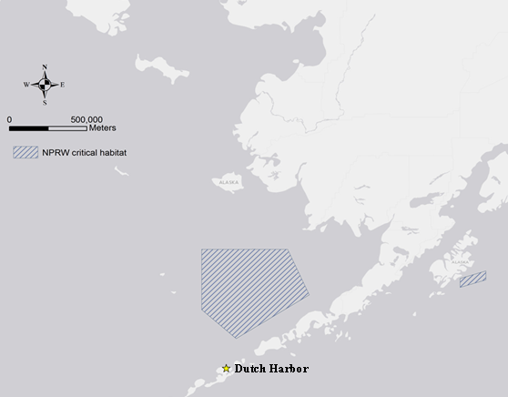
Figure 5. North Pacific right whale critical habitat in the Bering Sea and Gulf of Alaska.

North Pacific right whales and critical habitat in the action area
<describe for your project, example below

Overlap with North Pacific right whale critical habitat and project activities could occur during the infrequent need for a project specific delivery of materials to a project site. It is possible that the barge would pass through critical habitat.>

Fin Whale
The fin whale (Balaenoptera physalus) was decimated by commercial whaling in the 1800s and early 1900s. It was listed as an endangered species under the ESCA in 1970 (35 FR 8491, June 2, 1970 (baleen whales listing); 35 FR 18319, December 2, 1970 (fin whale listing)), and continued to be listed as endangered following passage of the ESA. Critical habitat has not been designated for fin whales.
Coastal and pelagic catch data from the first half of the twentieth century indicate that fin whales were not uncommon near Unalaska Bay and around Unalaska Island (Nishiwaki 1966; Reeves et al. 1985); however, fin whales have been documented infrequently around Unalaska Island since whaling ended (Stewart et al. 1987; Zerbini et al. 2006). High concentrations of fin whales are found around Kodiak Island, indicating the region’s importance for foraging (Angliss and Outlaw 2007; Stafford et al. 2007; Ferguson et al. 2015; Rone et al. 2017; Brower et al. 2022). Five passive acoustic monitoring sites in the Gulf of Alaska recorded fin whales year-round with more calls at sites on or near the continental shelf compared to seamount sites in deeper water (Rice et al. 2021).
Fin whale sounds have increasingly been recorded during surveys in the eastern Chukchi Sea (67°–72°N, 157°–169°W) from July to October primarily over the continental shelf (Brower et al. 2018). During similar aerial surveys in 1982–1991, there was a complete lack of sightings of these whales (Brower et al. 2018). Fin whale sightings have been increasing during surveys conducted in the U.S. portion of the northern Chukchi Sea from July to October, and fin whale calls were recorded each year from 2007 to 2010 in August and September in the northeastern Chukchi Sea and August to October just north of the Bering Strait, suggesting they may be re-occupying habitat used prior to large-scale commercial whaling (Muto et al. 2020).
In 2012, a fin whale was recorded by a passive recorder located 50 km north of Utqiagvik, Alaska, which was approximately 280 and 365 km northeast of the previous closest acoustic detection, and confirmed visual sighting, of a fin whale, respectively (Crance et al. 2015). A passive recorder located in the southern Chukchi Sea from 2012 to 2015 documented fin whale songs from August to November (Furumaki et al. 2021).
Fin whales produce a variety of low-frequency sounds in the 10 Hz to 0.2 kHz range (Thompson et al. 1992; Rice et al. 2021). While there is no direct data on hearing in low-frequency cetaceans, the applied frequency range is expected to be between 7 Hz and 35 kHz (NMFS 2018). Estimates based on scans of a fin whale calf skull indicate the range of best hearing for fin whale calves to range from approximately 20 Hz to 10 kHz, with maximum sensitivities between 1 to 2 kHz (Cranford and Krysl 2015).

Fin whales in the action area
<describe for your project, example below
Fin whales are typically found in deep water (Matsuoka et al. 2013; Rone et al. 2017) away from the immediate coast (Clarke et al. 2020); consequently it is unlikely that they would overlap with effects from coastally-based construction activities. However, project-dedicated barges could pass through waters occupied by fin whales.>
Additional information on fin whale biology and habitat is available at:
Fin Whale Species Description
Marine Mammal Stock Assessment Reports: Cetaceans-Large Whales
2019 Status Review

Blue Whale
The blue whale (Balaenoptera musculus) was listed as an endangered species under the ESCA in 1970 (35 FR 8491) and continued to be listed as endangered following the passage of the ESA. Although blue whales have been divided into stocks for management purposes under the MMPA, distinct population segments have not been adopted under the ESA. Blue whales from both the Northeast Pacific and Central/Western Pacific populations are found in Alaska ((Rice et al. 2020). A recovery plan was published in 1998 (NMFS 1998) but critical habitat has not been designated. Ship strike and entanglement with commercial fishing gear are two current sources of mortality (Carretta et al. 2020).
Blue whales were significantly depleted by commercial whaling activities worldwide. Between 1905 and 1971 an estimated 3,411 blue whales were removed from the eastern North Pacific by commercial whaling (Monnahan et al. 2014). An analysis of line-transect survey data from 1996-2014 provided a range of blue whale estimates from a high of approximately 2,900 whales in 1996 to a low of 900 whales in 2008 (Barlow 2016). Photographic mark-recapture estimates of abundance from 2005 to 2011 range from 1,000 to 2,300 whales (Calambokidis and Barlow 2013). The most recent abundance estimate for blue whales in the eastern North Pacific is 1,898 whales, based on the Chao model and the most recent data from 2015-2018 (Calambokidis and Barlow 2020).
The U.S. West Coast is an important feeding area in summer and fall for blue whales from the Eastern North Pacific stock, and they are increasingly found feeding north and south of this area in summer and fall. Most of this stock is believed to migrate south to spend the winter and spring in high productivity areas off Baja California, the Gulf of California, and on the Costa Rica Dome. Blue whales from the Central North Pacific stock feed southwest of Kamchatka, south of the Aleutians, and in the Gulf of Alaska during the summer, and migrate to lower latitudes in the western and central Pacific, including Hawaii in the winter (Carretta et al. 2020).
Blue whales make low frequency calls between 10 and 40 Hz lasting between ten and thirty seconds. NMFS categorizes blue whales in the low-frequency cetacean functional hearing group, with an applied frequency range between 7 Hz and 35 kHz (NMFS 2018).

Blue whales in the action area
<describe for your project, example below
Blue whale individuals are a deep water species (Matsuoka et al. 2013; Rone et al. 2017) and not expected to overlap with effects of coastal construction activities. However, if a project specific barge were needed, it could pass through habitat occupied by blue whales. >
More information on blue whale biology and habitat is available at:
Blue Whale Species Description
Marine Mammal Stock Assessment Reports: Cetaceans-Large Whales
2020 Status Review

Sperm Whale
The sperm whale (Physeter macrocephalus) was listed as an endangered species under the ESCA in 1970 (35 FR 8491), and continued to be listed as endangered following passage of the ESA. Critical habitat has not been designated for sperm whales.
Sperm whales are primarily found in deep waters, and sightings of sperm whales in water less than 300 m (984 ft) are uncommon. They are usually found far offshore, except in cases where the shelf break or submarine canyons occur close to land (Mizroch and Rice 2013). They feed primarily on medium-sized to large-sized squids but also take substantial quantities of large demersal and mesopelagic sharks, skates, and fishes (Rice 1989). The northern extent of their known range is 62°N, where Soviet catches of females occurred in Olyutorsky Bay (Muto et al. 2018). During summer, males are found in the Gulf of Alaska, Bering Sea, and waters around the Aleutian Islands (Mizroch and Rice 2013). There are no recent and reliable estimates for population size or trend for sperm whales off Alaska (i.e., the North Pacific Stock). A minimum estimate of the total annual level of human-caused mortality and serious injury for North Pacific sperm whales in 2013-2017 is 4.9 whales in U.S. commercial fisheries (Muto et al. 2020).
Sperm whales produce a variety of vocalizations ranging from 0.1 to 20 kHz (Weilgart and Whitehead 1993; Goold and Jones 1995; Møhl et al. 2003; Weir and Goold 2007). Sperm whales are odontocetes (toothed whales) and are considered mid-frequency cetaceans with an applied frequency range of 150 Hz to 160 kHz (NMFS 2018). The only direct measurement of hearing was from a young stranded individual from which auditory evoked potentials were recorded and indicated a hearing range of 2.5 to 60 kHz (Carder and Ridgway 1990).
Four of the most common threats cited for Southeast Alaska sperm whales are interactions with commercial fishing, whale watching, acoustic disturbance, and ship strikes (NMFS 2010). Neilson et al. (2012) found that out of the 89 defined whale strikes documented from 1978-2011 only one of those was a sperm whale, and the fate of that whale is unknown. The level of effects on sperm whales from ship noise is not fully understood but effects are expected to be similar to those described for humpback whales (NMFS 2010). Between 2012 and 2021, four suspected human-related sperm whale mortalities were reported to the Alaska Region Stranding Program.

Bering Sea/Aleutian Islands
Sperm whales have been frequently documented in the western Aleutian Islands, from Unalaska to the east out to the far islands. During 12 cetacean surveys in the summers of 2001-2007 and 2009-2010, 393 sightings of adult male sperm whales were made (Fearnbach et al. 2012). They were considered the most frequently sighted large cetacean in coastal waters around the central and western Aleutian Islands (Allen and Angliss 2011). In February 2008, a group of approximately 50 female and immature sperm whales were seen near Koniuji Island, in the central Aleutian Islands (Fearnbach et al. 2012). This was the first time such a large aggregation of females and juveniles were seen so far north since whaling ended.

Gulf of Alaska
Results from acoustic surveys indicate that sperm whales are present in the Gulf of Alaska year-round where they are most common in the summer months along the continental shelf waters (Mellinger et al. 2004a; Straley et al. 2014; Diogou et al. 2019). They have been documented interacting with demersal longline fisheries in the Gulf of Alaska since the 1970s (Straley et al. 2014; Wild et al. 2017; Hanselman et al. 2018). In July of 2021, a sperm whale became entangled in gear used by the Alaska Fisheries Science Center’s Alaska Longline Survey. The interaction resulted in a live release; the whale swam away with no visible gear wrapped around it and is assumed to have survived with no major effects (Eco49 2022).

Southeast Alaska
Sperm whales are widely distributed and may be present in waters of Southeast Alaska year-round (Muto et al. 2022), typically in deeper offshore waters. They have been documented interacting with demersal longline fisheries in the Gulf of Alaska since the 1970s (Wild et al. 2017). In 2019, a sperm whale carcass was found in Lynn Canal and the cause of death was determined to be trauma from a vessel strike (Freed et al. 2022).

Sperm whales in the action area
<describe for your project, example below
Because sperm whales occur in coastal waters of the central Aleutian Islands, there is the possibility that they might be near the action area of construction projects in these areas. Near Kodiak and the Gulf of Alaska they are typically found in deep water (Matsuoka et al. 2013; Rone et al. 2017); therefore, it is less likely that individual whales would overlap with the effects of project construction activities in these areas. However, if a project specific barge were needed, it could pass through habitat occupied by sperm whales.>
Additional information on sperm whale biology and habitat is available at:
Sperm Whale Species Description
2015 Status Review
Marine Mammal Stock Assessment Reports: Cetaceans-Large Whales

Sei Whale
The sei whale (Balaenoptera borealis) was listed as an endangered species under the ESCA in, 1970 (35 FR 12222) and continued to be listed as endangered following the passage of the ESA. Under the MMPA, two stocks of sei whales are currently recognized within the U.S. Pacific waters: Eastern North Pacific and Hawaii (Carretta et al. 2020). The two stocks are not recognized separately under the ESA. Critical habitat has not been designated for sei whales.
Sei whale abundance in the North Pacific pre-whaling was estimated to be 42,000 whales (Tillman 1977). Based on visual line-transect surveys conducted between 2010 and 2012, sei whale abundance in the central and eastern North Pacific is estimated at 29,632 whales (Hakamada et al. 2017). The best estimate of abundance for California, Oregon, and Washington waters is 519 whales, based on line transect surveys in 2008 and 2014 (Barlow 2016).
Sei whales are distributed far out to sea in temperate waters worldwide and do not appear to be associated with coastal features. In Alaskan waters, sei whales have been reported primarily south of the Aleutian Islands, in Shelikof Strait and waters surrounding Kodiak Island, in the Gulf of Alaska, and inside waters of southeast Alaska (Leatherwood et al. 1982). The fine baleen structure of the sei whales allows them to skim the surface waters for patches of their preferred copepod prey. Sei whales also feed on euphausiids, shoals of fish, and squid if they are encountered (Harwood 2017).
Sei whales make low and mid frequency vocalizations including upsweep and downsweep calls, pulse trains, and growls. NMFS categorizes sei whales in the low-frequency cetacean functional hearing group, with an applied frequency range between 7 Hz and 35 kHz (NMFS 2018).

Sei whales in the action area
<describe for your project, example below>
Because sei whales are not associated with coastal features we do not expect that any individuals would be affected by effects from coastal construction projects. It is possible that a project-dedicated barge could pass over habitat occupied by sei whales.
More information on sei whale biology and habitat is available at:
Sei Whale Species Description
Marine Mammal Stock Assessment Reports: Cetaceans-Large Whales
2021 Status Review
2016 Recovery Plan

Cook Inlet Beluga Whale
Cook Inlet beluga whales are geographically and genetically isolated from other beluga whale stocks in Alaska. NMFS designated the Cook Inlet beluga (Delphinapterus leucas) population as depleted under the MMPA in 2000 (65 FR 34590; May 31, 2000) after its population dropped from approximately 1,300 individuals in 1979 to 347 in 1998. A lack of subsequent population growth led NMFS to list the Cook Inlet beluga as endangered under the ESA on December 22, 2008 (73 FR 62919; October 22, 2008). Currently, the best abundance estimate for the Cook Inlet beluga whale population is 279 whales (95 percent probability interval 250 to 317) based on a 2018 beluga aerial survey (Shelden and Wade 2019).
Although they remain year-round in Cook Inlet, they demonstrate seasonal movements within the inlet. In general, during the summer and fall, beluga whales occur in shallow coastal waters and are concentrated near the Susitna River Delta, Knik Arm, Turnagain Arm, Chickaloon Bay, and near Fire Island in the upper inlet (Shelden et al. 2015; Castellote et al. 2016; McGuire et al. 2020), and the Kenai River Delta in the lower Inlet (McGuire et al. 2020). During the winter, they are more dispersed, occurring in deeper waters in the mid-inlet to Kalgin Island, and in the shallow waters along the west shore of Cook Inlet to Kamishak Bay. While ice formation in the upper inlet was once thought to restrict beluga’s access to nearshore habitat (Ezer et al. 2013), tagging data, acoustic studies, and opportunistic sightings indicate that Cook Inlet belugas continue to occur in the upper inlet throughout the winter months, in particular the coastal areas from Trading Bay to Little Susitna River, with foraging behavior detected in lower Knik Arm and Chickaloon Bay, and also detected in several areas of the lower inlet such as the Kenai River, Tuxedni Bay, Big River, and NW Kalgin Island (Shelden et al. 2015; Shelden et al. 2018; Castellote et al. 2020; Castellote et al. 2021).
The distribution of Cook Inlet belugas has changed significantly since the 1970s. Information on Cook Inlet beluga distribution, including aerial surveys and acoustic monitoring, indicates that the species’ range in Cook Inlet has contracted markedly since the 1990s (Shelden and Wade 2019). This distributional shift and range contraction coincided with the decline in abundance (Moore et al. 2000; NMFS 2008a; Goetz et al. 2012). While belugas are concentrated primarily in the upper inlet during the summer and fall months, the area around the East Forelands between Nikiski, Kenai, and Kalgin Island as well as Tuxendi Bay appears to provide important habitat in winter, early spring, and fall (NMFS unpublished data).
Cook Inlet beluga whales have diverse diets (Quakenbush et al. 2015; Nelson et al. 2018), foraging on fish and benthos, often at river mouths. Primary prey species consist of four species of Pacific salmon (Chinook, sockeye, chum, and coho), Pacific eulachon, Pacific cod, walleye pollock, saffron cod, and yellowfin sole. Belugas seasonally shift their distribution within Cook Inlet in relation to the timing of fish runs and seasonal changes in ice and currents (NMFS 2016).
NMFS categorizes Cook Inlet beluga whales in the mid-frequency cetacean functional hearing group, with an applied frequency range between 150 Hz and 160 kHz (NMFS 2018).
More information on Cook Inlet beluga whales is available at:
Beluga Whale Species Description
Marine Mammal Stock Assessment: Cetaceans-Small Whales
2022 Status Review
2016 Recovery Plan
Cook Inlet Beluga Critical Habitat

Cook Inlet Beluga Whale Critical Habitat
NMFS designated critical habitat for the Cook Inlet beluga whale on May 11, 2011 (76 FR 20180; April 11, 2011), delineating two areas (aptly named Area 1 and Area 2) that generally describe summer vs. winter habitat, respectively (Figure 6).

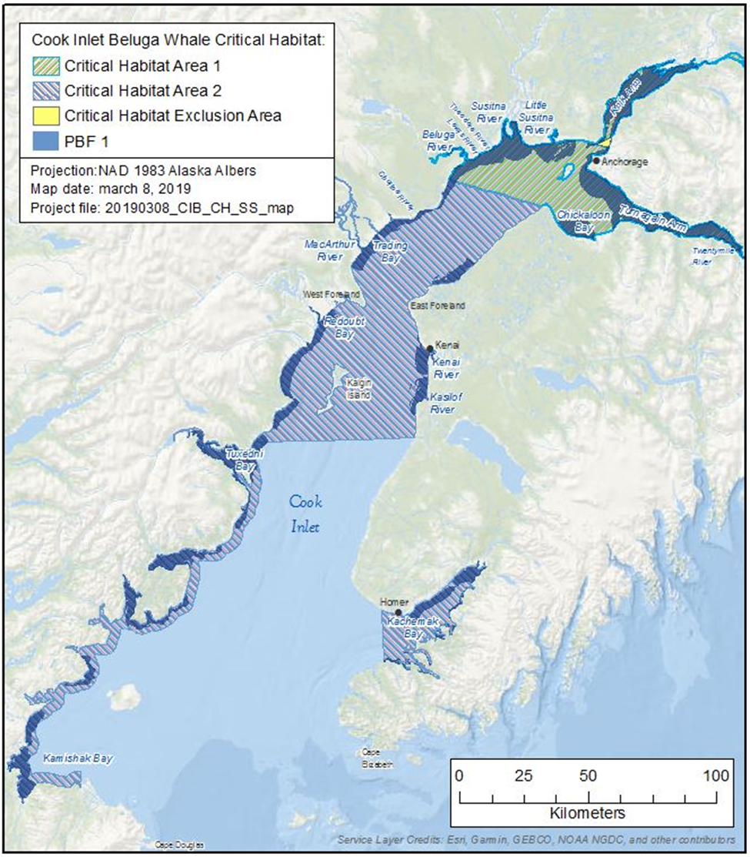
Figure 6. Cook Inlet Beluga Whale Critical Habitat (50 CFR § 226.220).
Cook Inlet beluga whale critical habitat includes five Physical or Biological Features (PBFs) that were deemed essential to the conservation of the stock:
- Intertidal and subtidal waters of Cook Inlet with depths less than 30 feet mean low low water (MLLW) and within five miles of high and medium flow anadromous fish streams.
- Primary prey species consisting of four species of Pacific salmon (Chinook, sockeye, chum, and coho), Pacific eulachon, Pacific cod, walleye Pollock, saffron cod, and yellowfin sole.
- Waters free of toxins or other agents of a type and amount harmful to Cook Inlet beluga whales.
- Unrestricted passage within or between the critical habitat areas.
- Waters with in-water noise below levels resulting in the abandonment of critical habitat areas by Cook Inlet beluga whales.
NMFS excluded from critical habitat two areas in upper Cook Inlet near the Port of Anchorage and Joint Base Elmendorf-Richardson (50 CFR § 226.220).

Cook Inlet beluga whales and critical habitat in the action area
<describe for your project, example below
Because no project considered in this programmatic may occur within 10 nm of Cook Inlet beluga whale critical habitat, and critical habitat represents the area where the belugas are most frequently, it is very unlikely that belugas would be exposed to effects from coastal projects covered by this programmatic consultation.>

Humpback Whale
The humpback whale (Megaptera novaeangliae) was listed as endangered under the ESCA on June 2, 1970 (35 FR 8491, baleen whales listing; 35 FR 18319, December 2, 1970, humpback whale listing). Congress replaced the ESCA with the ESA in 1973, and humpback whales continued to be listed as endangered. NMFS conducted a global status review that led to changing the status of humpback whales under the ESA and dividing the species into 14 distinct population segments (DPS) (81 FR 62260, September 8, 2016). Of these 14 DPSs, NMFS listed four as endangered, one as threatened, and delisted the remaining nine. Three DPSs occur in waters of Alaska. The Western North Pacific DPS is listed as endangered; the Mexico DPS is listed as threatened; and the Hawaii DPS is not listed (81 FR 62260, September 8, 2016).
The Hawaii DPS population is estimated to be 11,540 animals (CV=0.04) with an annual growth rate between 5.5 and 6.0 percent. The Mexico DPS is comprised of approximately 2,913 animals (CV=0.7; Wade 2021) with an unknown, but likely declining, population trend (81 FR 62260; September 8, 2016). Approximately, 1,084 animals (CV=0.09) comprise the Western North Pacific DPS (Wade 2021). Humpback whales in the Western North Pacific remain rare in some parts of their former range, such as the coastal waters of Korea, and have shown little sign of recovery in those locations.
Whales from these three DPSs overlap on feeding grounds off Alaska, and are visually indistinguishable unless individuals have been photo-identified on breeding grounds and again on feeding grounds. All waters off the coast of Alaska may contain ESA-listed humpbacks.
Humpback whales produce a variety of vocalizations ranging from 20 Hz to 10 kHz (Silber 1986; Richardson et al. 1995; Au 2000; Erbe 2002; Au et al. 2006; Vu et al. 2012). NMFS categorizes humpback whales in the low-frequency cetacean functional hearing group, with an applied frequency range between 7 Hz and 35 kHz (NMFS 2018).

Bering Sea/Aleutian Islands/Chukchi and Beaufort Seas
The abundance estimate for humpback whales in the Bering Sea and Aleutian Islands is estimated to be 7,758 (CV= 0.2) animals, which includes whales from the Hawaii DPS (91 percent), Mexico DPS (7 percent), and Western North Pacific DPS (2 percent; NMFS 2021; Wade 2021)(Table 3). These same DPS proportions apply for the Chukchi and Beaufort seas. Humpback whales have increasingly been recorded during surveys in the eastern Chukchi Sea (67°–72°N, 157°–169°W) from July to October primarily over the continental shelf (Brower et al. 2018). During similar aerial surveys in 1982–1991, there was a complete lack of sightings of these whales (Brower et al. 2018). It is unknown if this is an indicator of population recovery, climate change, or increased survey effort (Brower et al. 2018).
The area around the Aleutian Islands from Umnak Island northeastward along the Alaska Peninsula has been identified as a Biologically Important Area for humpback whales (Brower et al. 2022). Telemetry data from Kennedy et al. (2014) supported findings of historical data showing that humpback whales congregate in the shallow, highly productive coastal waters north of the eastern Aleutian Islands, between Unimak and Samalga Passes. The extremely high proportion of foraging within the narrow band 200 km east and west of Unalaska Bay further emphasizes the importance of the waters off the eastern Aleutian Islands for humpback whales (Kennedy et al. 2014). Annual vessel-based, photo-identification surveys in the Shumagin Islands from 1999 to 2015 identified 654 unique individual humpback whales between June and September (Witteveen and Wynne 2017).

Gulf of Alaska
The abundance estimate for humpback whales in the Gulf of Alaska is 2,129 (CV=0.08) animals, which includes whales from the Hawaii DPS (89 percent), Mexico DPS (11 percent), and Western North Pacific DPS (1 percent; Wade 2021)(Table 3). Humpback whales occur throughout the central and western Gulf of Alaska from Prince William Sound to the Shumagin Islands. Seasonal concentrations are found in coastal waters of Prince William Sound, Barren Islands, Kodiak Archipelago, Shumagin Islands, and south of the Alaska Peninsula. Large numbers of humpbacks have also been reported in waters over the continental shelf, extending up to 100 nm offshore in the western Gulf of Alaska (Rone et al. 2017; Wade 2021).

Southeast Alaska
Relatively high densities of humpback whales occur throughout much of Southeast Alaska and northern British Columbia, particularly during the summer months. The abundance estimate for humpback whales in Southeast Alaska is estimated to be 5,890 (CV= 0.08) animals, which includes whales from the Hawaii DPS (98 percent) and Mexico DPS (2 percent; Wade 2021)(Table 3). Although migration timing varies among individuals, most whales depart for Hawaii or Mexico in fall or winter and begin returning to Southeast Alaska in spring, with continued returns through the summer and a peak occurrence in Southeast Alaska during late summer to early fall. However, there are significant overlaps in departures and returns (Baker et al. 1985; Straley 1990).
Table 3. Percent probability of encountering humpback whales from each DPS in the North Pacific Ocean (columns) in various feeding areas (on left; Wade 2021).
Summer Feeding Areas | North Pacific Distinct Population Segments (DPS) (percent)
 | Western North Pacific (endangered) | Hawaii  (not listed) | Mexico (threatened) | Central America (endangered)
Kamchatka | 91 | 9 | 0 | 0
Aleutian I / Bering / Chukchi Seas | 2 | 91 | 7 | 0
Gulf of Alaska | 1 | 89 | 11 | 0
Southeast Alaska / Northern BC | 0 | 98 | 2 | 0
Southern BC / WA | 0 | 69 | 25 | 6
OR/CA | 0 | 0 | 58 | 42
Note that in the past iteration of this guidance, upper confidence intervals were used for endangered DPSs.
However, the revised estimates do not have associated coefficients of variation to cite. Therefore, the point estimate is being used for each probability of occurrence.
Additional information on humpback whale biology and natural history is available at:
Humpback Whale Species Description
Marine Mammal Stock Assessment Reports: Cetaceans-Large Whales
Humpback Whale Critical Habitat

Humpback Whale Critical Habitat
Critical habitat for the Mexico and Western North Pacific DPS humpback whales was designated May 21, 2021 (86 FR 21082, April 21, 2021; Figure 7). Critical habitat for the Western North Pacific DPS includes areas in the eastern Aleutian Islands, the Shumagin Islands, and around Kodiak Island, and for the Mexico DPS includes those same areas plus the Prince William Sound area.
For the Mexico DPS, the physical and biological features associated with critical habitat include: prey species, primarily euphausiid zooplankton and small pelagic schooling fishes, such as Pacific sardines, northern anchovy, Pacific herring, capelin, juvenile walleye pollock and Pacific sand lance of sufficient quality, abundance, and accessibility within humpback whale feeding areas to support feeding and population growth.
For the Western North Pacific DPS, the physical and biological features associated with critical habitat include: prey species, primarily euphausiid zooplankton and small pelagic schooling fishes, such as Pacific herring, capelin, juvenile walleye pollock, and Pacific sand lance of sufficient quality, abundance, and accessibility within humpback whale feeding areas to support feeding and population growth.

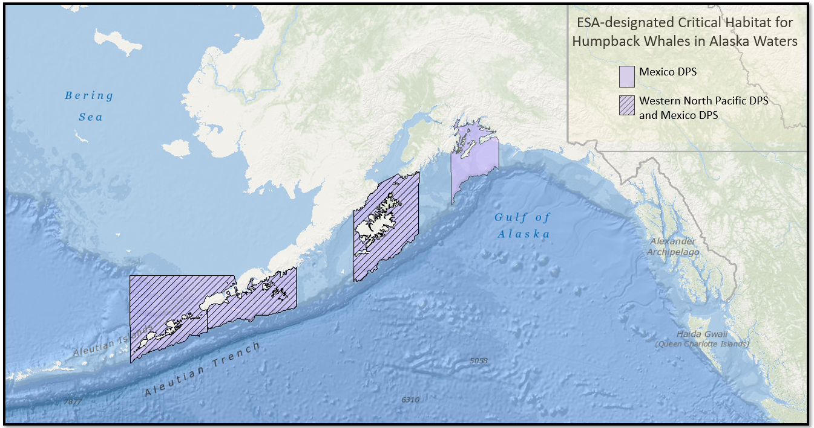
Figure 7. Critical habitat for Mexico DPS and Western North Pacific DPS humpback whales in waters off Alaska.

Humpback whales and critical habitat in the action area
<describe for your project, example below
Given their widespread range, relative abundance, their opportunistic foraging strategies, and frequent near-shore occurrence, Mexico DPS humpback whales may occur in the vicinity of projects covered in this programmatic consultation.>
For information on occurrence of humpback whale Distinct Population Segments off Alaska see Humpback Whale Guidance, (link available here).

Western DPS Steller Sea Lion
The Steller sea lion (Eumetopias jubatus) was listed as a threatened species under the ESA on December 4, 1990 (55 FR 49204, November 26, 1990). On June 4, 1997, NMFS reclassified Steller sea lions into two DPS’s based on genetic studies and other information (62 FR 24345, May 5, 1997); at that time the eastern DPS was listed as threatened and the Western DPS was listed as endangered. On December 4, 2013, the eastern DPS was removed from the endangered species list (78 FR 66140, November 4, 2013).
Steller sea lions range throughout the North Pacific Ocean from Japan, east to Alaska, and south to central California (Loughlin et al. 1984). They range north to the Bering Strait, with significant numbers at haul-outs on St. Lawrence Island in the spring and fall (Kenyon and Rice 1961). Breeding range extends along the northern edge of the North Pacific Ocean from the Kuril Islands, Japan, through the Aleutian Islands and Southeast Alaska, and south to California (Loughlin et al. 1984). Based on Hastings et al. (2020), NMFS concludes that Western DPS Steller sea lions are common north of Sumner Strait.
Rookery and haulout sites are located on isolated islands, rocky shorelines, and jetties from Cape Suckling, through the Bering Sea and into the Sea of Okhotsk (Muto et al. 2020). Steller sea lions are not known to migrate annually, but individuals may widely disperse outside of the breeding season (Raum-Suryan et al. 2004; Trites et al. 2006; Lander et al. 2009; Jemison et al. 2013; Fritz et al. 2016; Sigler et al. 2017). Males arrive at breeding sites in May with females following shortly afterwards, and pups are born from mid-May to early July, with a peak in mid-June. During summer, Steller sea lions feed mostly over the continental shelf and shelf edge. Females attending pups forage within 20 nm of breeding rookeries (Merrick and Loughlin 1997), which is the basis for designated critical habitat around rookeries and major haulout sites.
The foraging strategy of Steller sea lions is strongly influenced by seasonality of sea lion reproductive activities on rookeries and the ephemeral nature of many prey species. Steller sea lions are generalist predators that eat a variety of fishes and cephalopods (Pitcher and Calkins 1981; Calkins and Goodwin 1988; NMFS 2008b), and occasionally other marine mammals and birds (Pitcher and Fay 1982; NMFS 2008b).
The ability to detect sound and communicate underwater is important for a variety of Steller sea lion life functions, including reproduction and predator avoidance. NMFS categorizes Steller sea lions in the otariid pinniped functional hearing group, with an applied frequency range between 60 Hz and 39 kHz in water (NMFS 2018).
Information on Steller sea lion biology and habitat is available at:
Steller Sea Lion Species Description
Marine Mammal Stock Assessment Reports: Pinnipeds-Otariidshttps://www.fisheries.noaa.gov/species/steller-sea-lion
2018 Status Review
Steller Sea Lion Critical Habitat

Steller Sea Lion Critical Habitat
NMFS designated critical habitat for Steller sea lions on August 27, 1993 (58 FR 45269; Figure 8 and Figure 9). In Alaska, designated critical habitat includes the following areas as described at 50 CFR § 226.202.
- Terrestrial zones that extend 3,000 feet (0.9 km) landward from each major haulout and major rookery in Alaska.
- Air zones that extend 3,000 feet (0.9 km) above the terrestrial zone of each major haulout and major rookery in Alaska.
- Aquatic zones that extend 3,000 feet (0.9 km) seaward of each major haulout and major rookery in Alaska that is east of 144º W longitude.
- Aquatic zones that extend 20 nm (37 km) seaward of each major haulout and major rookery in Alaska that is west of 144º W longitude.
- Three special aquatic foraging areas: the Shelikof Strait area, the Bogoslof area, and the Seguam Pass area, as specified at 50 CFR § 226.202(c).
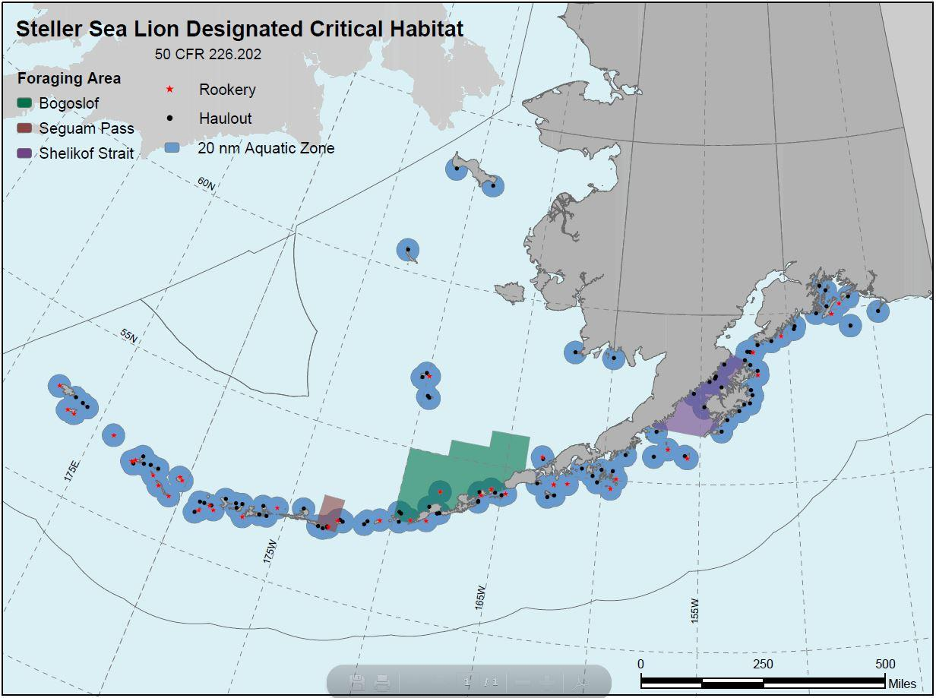
Figure 8. Designated Steller sea lion critical habitat in Alaska.

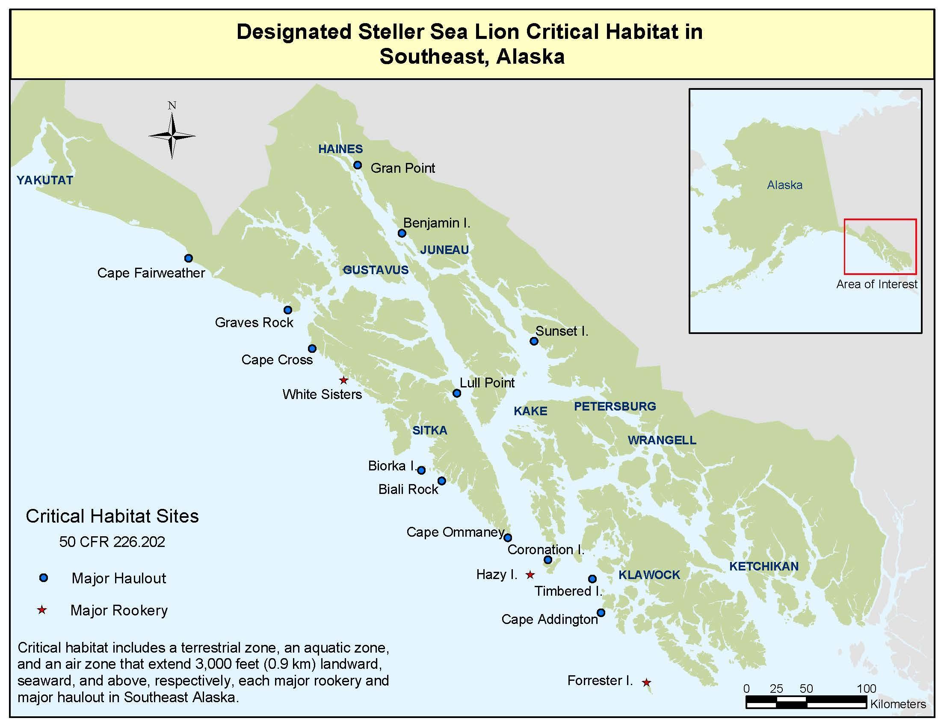
Figure 9. Designated critical habitat for Steller sea lions in Southeast Alaska

WDPS Steller sea lions and critical habitat in the action area
<describe for your project, example below
Although we do not know where projects will occur, it is possible that some projects will be proposed within critical habitat for Steller sea lions and/or that project specific barges will need to pass through critical habitat.>
For information on occurrence of western Distinct Population Segment of Steller Sea lion East of 144°W longitude see guidance (link available here).

Sunflower Sea Star
On August 18, 2021, the Center for Biological Diversity petitioned NMFS to list the sunflower sea star (Pycnopodia helianthoides) under the ESA. NMFS determined that the proposed action may be warranted (86 FR 73230, December 27, 2021) and began a full status review to evaluate overall extinction risk for the species. NMFS determined that the sunflower sea star is likely to become an endangered species within the foreseeable future throughout its range and on March 16, 2023, published a proposed rule to list the sunflower sea star as a threatened species (88 FR 16212). NMFS did not propose to designate critical habitat at this time.
The sunflower sea star is a large (up to 1 m in diameter), fast-moving (up to 160 cm/minute), many-armed (up to 24) echinoderm native to the west coast of North America (Lowry et al. 2022). It occupies waters from the intertidal to at least 435 m deep, but is most common at depths less than 25 m and rare in waters deeper than 120 m (Lambert 2000; Hemery et al. 2016; Gravem et al. 2021). Sunflower sea stars occur over a broad array of soft-, mixed-, and hard-bottom habitats from the Aleutian Islands to Baja California, Mexico, but are most abundant in waters off eastern Alaska and British Columbia (Gravem et al. 2021).
Prior to 2013, the global abundance of sunflower sea star was estimated at several billion animals, but from 2013–2017 sea star wasting syndrome (SSWS) reached pandemic levels, killing an estimated 90 percent or more of the population (Lowry et al. 2022). Declines in the northern portion of its range were less pronounced than in the southern portion, but still exceeded 60 percent. Species-level impacts from SSWS, both during the pandemic and on an ongoing basis, have been identified as the major threat affecting the long-term persistence of the sunflower sea star (Lowry et al. 2022).
The species has separate sexes and is a broadcast spawner with a planktonic larval stage (Lundquist and Botsford 2011). Females can release a million eggs or more (Strathmann 1987; Chia and Walker 1991; Byrne 2013). Reproduction also occurs via larval cloning, enhancing potential reproductive output beyond female fecundity (Bosch et al. 1989; Balser 2004). Sea stars also have the ability to regenerate lost rays/arms and parts of the central disc (Chia and Walker 1991). Rays may detach when a sea star is injured or as a defense reaction when attacked by a predator. The longevity of P. helianthoides in the wild is unknown, as is the age at first reproduction and the period over which a mature individual is capable of reproducing (Lowry et al. 2022).
The sunflower sea star hunts a range of bivalves, gastropods, crustaceans, and other invertebrates using chemosensory stimuli and will dig for preferred prey in soft sediment (Mauzey et al. 1968; Paul and Feder 1975; Herrlinger 1983). It preys on sea urchins and plays an important role in controlling sea urchin numbers in kelp forests (Lowry et al. 2022). While generally solitary, they are also known to seasonally aggregate, perhaps for spawning purposes.

Sunflower sea stars in the action area
<insert project-specific information>
More information on the sunflower sea star can be found at:
Proposed Rule to List Sunflower Sea Stars as Threatened Under the ESA
Sunflower Sea Star Status Review

Effects Determinations
For purposes of the ESA, “effects of the action” means all consequences to listed species or critical habitat that are caused by the proposed action. A consequence is caused by the proposed action if it would not occur but for the proposed action and it is reasonably certain to occur. Effects of the action may occur later in time and may include consequences occurring outside the immediate area involved in the action (50 CFR § 402.02). The applicable standard to find that a proposed action is “not likely to adversely affect” listed species or critical habitat is that all of the effects of the action are expected to be insignificant, extremely unlikely to occur, or completely beneficial. “Insignificant effects” relate to the magnitude of the impact and are those that one would not be able to meaningfully measure, detect, or evaluate; insignificant effects should never reach the scale where take occurs.

The potential effects of the proposed action on listed species and critical habitat include <insert stressors such as acoustic disturbance (noise) and habitat alteration>.

Acoustic Thresholds (Only include this section for projects with acoustic stressors)
We followed NMFS standards to determine conservative thresholds of underwater sound pressure levels, expressed in root mean square (rms), from broadband sounds that cause behavioral disturbance, and referred to as Level B harassment under section 3(18)(A)(ii) of the Marine Mammal Protection Act (MMPA; 16 U.S.C. § 1362(18)(A)(ii)):
- impulsive sound: 160 dB_{rms} re 1 μPa
- continuous sound: 120 dB_{rms} re 1μPa

The generalized hearing range for each hearing group is provided in Table 4.
Table 4. Underwater marine mammal hearing groups (NMFS 2018).
Hearing Group | ESA-listed Marine Mammals In the Action Area | Generalized Hearing Range¹
Low-frequency (LF) cetaceans  (Baleen whales) | <Bowhead whales> | 7 Hz to 35 kHz
Mid-frequency (MF) cetaceans  (dolphins, toothed whales, beaked whales) | <Cook Inlet beluga whales> | 150 Hz to 160 kHz
High-frequency (HF) cetaceans  (true porpoises) | <None> | 275 Hz to 160 kHz
Phocid pinnipeds (PW)  (true seals) | Ringed and bearded seals | 50 Hz to 86 kHz
Otariid pinnipeds (OW)  (sea lions and fur seals) | <Western DPS Steller sea lion> | 60 Hz to 39 kHz
¹Respresents the generalized hearing range for the entire group as a composite (i.e., all species within the group), where individual species’ hearing ranges are typically not a broad. Generalized hearing range chosen based on ~65 db threshold from normalized composite audiogram, with the exception for lower limits for LF cetaceans (Southall et al. 2007) and PW pinniped (approximation).

Use the following paragraph only if in-air sound is an issue of concern
In addition, NMFS uses the following thresholds for in-air sound pressure levels from broadband sounds that cause Level B behavioral disturbance under section 3(18)(A)(ii) of the MMPA (16 U.S.C. § 1362(18)(A)(ii)):
- 100 dB_{rms} re 20μPa for non-harbor seal pinnipeds
Now that you’ve discussed the thresholds, discuss specific acoustic effects for this action.

<Insert first type of effect> (e.g. Acoustic Disturbance)
Describe the effects of the action on each listed species and critical habitat using a logical organization with subheadings for each type of effect: noise, habitat alteration, etc. This is where it may help to deconstruct the action into logical components and assess these individually (e.g., you may want to discuss in-water noise separately from other construction-related noise). Identify any sources of uncertainty. If possible, explain any absence of exposure to the threats (e.g., noise will occur during a season when the species isn’t present). Discuss the timing, duration, frequency, and severity of expected effects. Discuss the species’ likely response. Use facts from the record and your own reasoning to articulate a rational explanation for why each effect is insignificant, extremely unlikely to occur, or entirely beneficial. End each subsection in your analysis with a determination. For example: “NMFS concludes that the effects of habitat alteration on beluga whales will be immeasurably small, and acoustic effects on beluga whales will be extremely unlikely to occur due to the use of observers and shutdown zones.”
It is critical that consultations analyze the effects of the action when added to baseline conditions; that is, what is the effect of the stressors when added to the baseline conditions (e.g., if the area already is very noisy, you consider the effect of additional noise on top of an already noisy environment, or if you are considering vessel traffic you consider the effect of the addition of project related vessels to vessels that are already operating in the action area).
For example, “When this project is completed, it will not result in an increased number of vessels in the action area, and thus, there is no increased risk of vessel strike in the future. We have also considered the likelihood that an increase in vessel traffic related to the activities associated with the proposed project would generally increase the risk of interactions between marine mammals and vessels in the action area, in addition to baseline conditions. The use of a barge will cause a small, localized, temporary increase in vessel traffic. Given the extremely small increase in vessel traffic above existing levels in this reach of Icy Strait, there will be no measurable or detectable increase in the risk of vessel strike, and effects to western DPS Steller sea lion and Mexico DPS humpback whales are insignificant.”

Conclusion
Based on the analysis that all effects of the proposed action will be insignificant and/or discountable, we have determined that <insert proposed action> is not likely to adversely affect any listed species or critical habitat under NMFS’s jurisdiction. We have used the best scientific and commercial data available to complete this analysis. We request your concurrence with this determination.

Please direct any questions regarding this letter to <name>, <your phone number>.

Sincerely,

References
Provide a complete citation for any references included in this letter (Please note: the literature cited is very important because in order to determine if we concur with your NLAA determination, we may need to review the literature that you used as a basis for your determination.)

Allen, B. M., and R. P. Angliss. 2011. Alaska marine mammal stock assessments, 2010. U.S. Dept. of Commerce, National Oceanic and Atmospheric Administration, National Marine Fisheries Service, Alaska Fisheries Science Center, Seattle, WA, May 2011. NOAA Technical Memorandum NMFS-AFSC-223, 292 p.
Angliss, R. P., and R. B. Outlaw. 2007. Alaska marine mammal stock assessments, 2006. U.S. Dept. of Comemrce, National Oceanic and Atmospheric Administration, National Marine Fisheries Service, Alaska Fisheries Science Center, Seattle, WA, January 2007. NOAA Technical Memorandum NMFS-AFSC-168, 244 p.
Au, W. W. L. 2000. Hearing in whales and dolphins: An overview. Pages 1-42 in W. W. L. Au, A. N. Popper, and R. R. Fay, editors. Hearing by Whales and Dolphins. Springer-Verlag, New York.
Au, W. W. L., A. A. Pack, M. O. Lammers, L. M. Herman, M. H. Deakos, and K. Andrews. 2006. Acoustic properties of humpback whale songs. Journal of the Acoustical Society of America 120(2):1103-1110.
Baker, C. S., L. M. Herman, A. Perry, W. S. Lawton, J. M. Straley, and J. H. Straley. 1985. Population characteristics and migration of summer and late-season humpback whales (Megaptera novaeangliae) in southeastern Alaska. Marine Mammal Science 1(4):304-323.
Balser, E. J. 2004. And then there were more: cloning by larvae of echinoderms. Pages 3–9 in T. Heinzeller, and J. H. Nebelsick, editors. Echinoderms: München. A. A. Balkema Publishers, Leiden, London, New York, Philadelphia, Singapore.
Barlow, J. 2016. Cetacean abundance in the California Current estimated from ship-based line-transect surveys in 1991–2014, 63.
Bengtson, J. L., L. M. Hiruki-Raring, M. A. Simpkins, and P. L. Boveng. 2005. Ringed and bearded seal densities in the eastern Chukchi Sea, 1999–2000. Polar Biology 28(11):833-845.
Bosch, I., R. B. Rivkin, and S. P. Alexander. 1989. Asexual reproduction by oceanic planktotrophic echinoderm larvae. Nature 337:169–170.
Braham, H. W., J. J. Burns, G. A. Fedoseev, and B. D. Krogman. 1984. Habitat partitioning by ice-associated pinnipeds: Distribution and density of seals and walruses in the Bering Sea, April 1976. Pages 25-47 in F. H. Fay, and G. A. Fedoseev, editors. Soviet-American Cooperative Research on Marine Mammals. Volume 1 - Pinnipeds, volume NOAA Technical Report NMFS 12. National Oceanic and Atmospheric Administration, National Marine Fisheries Service, Washington, D. C.
Brower, A., A. Willoughby, and M. Ferguson. 2022. Distribution and relative abundance of bowhead whales and other marine mammals in the western Beaufort Sea, 2020. U.S. Dept. of Commerce, National Oceanic and Oceanic Administration, National Marine Fisheries Service, Alaska Fisheries Science Center, Seattle, WA, July 2022. NOAA Technical Memorandum NMFS-AFSC-439, 155 p.
Brower, A. A., J. T. Clarke, and M. C. Ferguson. 2018. Increased sightings of subArctic cetaceans in the eastern Chukchi Sea, 2008–2016: population recovery, response to climate change, or increased survey effort? Polar Biology 41(5):1033-1039.
Brownell Jr, R. L., T. Kasuya, and D. Weller. 2007. Entrapment of western gray whales in Japanese fishing gear: population threats, Paper SC/59/BRG38 presented to the International Whaling Commission Scientific Committee, Anchorage, AK, May 2007.
Burns, J. J. 1981. Bearded seal Erignatus barbatus Erxleben, 1777. Handbook of Marine Mammals Volume 2: Seals:145-170.
Byrne, M. 2013. Chapter 5: Asteroid evolutionary developmental biology and ecology. Pages 51-58 in J. M. Lawrence, editor. Starfish: biology and ecology of the Asteroidea. The Johns Hopkins University Press, Baltimore, MD.
Calambokidis, J., and J. Barlow. 2013. Updated abundance estimates of blue and humpback whales off the US West Coast incorporating photo-identifications from 2010 and 2011., 8.
Calambokidis, J., and J. Barlow. 2020. Updated abundance estimates for blue and humpback whales along the US West Coast using data through 2018. U.S. Dept. of Commerce, National Oceanic and Atmospheric Administration, National Marine Fisheries Service, Southwest Fisheries Science Center, San Diego, CA, September 2020. NOAA Technical Memorandum NOAA-TM-NMFS-SWFSC-634.
Calkins, D. G., and E. Goodwin. 1988. Investigation of the declining sea lion population in the Gulf of Alaska. Alaska Dept. of Fish and Game, Anchorage, AK, August 1988, 76 p.
Cameron, M. F., J. L. Bengtson, P. L. Boveng, J. K. Jansen, B. P. Kelly, S. P. Dahle, E. A. Logerwell, J. E. Overland, C. L. Sabine, G. T. Waring, and J. M. Wilder. 2010. Status review of the bearded seal (Erignathus barbatus). U.S. Department of Commerce, National Marine Fisheries Service, Alaska Fisheries Science Center, Seattle, WA, December 2010. NOAA Tech. Memo. NMFS-AFSC-211, 246 p.
Carder, D. A., and S. H. Ridgway. 1990. Auditory brainstem response in a neonatal sperm whale, Physeter spp. The Journal of the Acoustical Society of America 88(S4 (1990)).
Carretta, J. V., K. A. Forney, E. M. Oleson, D. W. Weller, A. R. Lang, J. Baker, M. M. Muto, B. Hanson, A. J. Orr, H. Huber, M. S. Lowry, J. Barlow, J. E. Moore, D. Lynch, L. Carswell, and R. L. B. Jr. 2020. U.S. Pacific marine mammal stock assessments: 2019. U.S. Dep. Commer., NOAA, NMFS, Southwest Fisheries Science Center, August 2020. NOAA Technical Memorandum NMFS-SWFSC-629.
Carretta, J. V., E. M. Oleson, K. A. Forney, M. M. Muto, D. W. Weller, A. R. Lang, J. Baker, B. Hanson, A. J. Orr, J. Barlow, J. E. Moore, and R. L. B. Jr. 2022. U.S. Pacific marine mammal stock assessments: 2021.
Castellote, M., A. Mooney, R. Andrews, S. Deruiter, W.-J. Lee, M. Ferguson, and P. Wade. 2021. Beluga whale (Delphinapterus leucas) acoustic foraging behavior and applications for long term monitoring. PLoS One 16(11):e0260485.
Castellote, M., R. J. Small, M. Lammers, J. Jenniges, J. Mondragon, C. D. Garner, S. Atkinson, J. Delevaux, R. Graham, and D. Westerholt. 2020. Seasonal distribution and foraging occurrence of Cook Inlet beluga whales based on passive acoustic monitoring. Endangered Species Research v41.
Castellote, M., R. J. Small, M. O. Lammers, J. J. Jenniges, J. Mondragon, and S. Atkinson. 2016. Dual instrument passive acoustic monitoring of belugas in Cook Inlet, Alaska. Journal of the Acoustical Society of America 139(5):2697-2707.
Chia, F. S., and C. W. Walker. 1991. Ch. 5. Echinodermata: Asteroidea. Pages pp. 301–353 in A. C. Giese, J. S. Pearse, and V. B. Pearse, editors. Reproduction of Marine Invertebrates Vol. VI-Echinoderms and Lophophorates. Boxwood Press.
Citta, J. J., G. A. Breed, S. R. Okonnen, M. L. Druckenmiller, L. Quakenbush, J. C. George, B. Adams, W. Maslowski, R. Osinski, and J. Olnes. 2023. Shifts in bowhead whale distribution, behavior, and condition following rapid sea ice change in the Bering sea. Continental Shelf Research:104959.
Citta, J. J., L. Quakenbush, and C. George. 2020. Distribution and behavior of Bering-Chukchi-Beaufort bowhead whales as inferred by telemetry. Pages 31-56 in J. C. George, and J. G. M. H. Thewissen, editors. The Bowhead Whale: Balaena mysticetus: biology and human Interactions. Elsevier Science & Technology, San Diego, CA.
Clarke, J., A. Brower, M. Ferguson, A. Willoughby, and A. Rotrock. 2020. Distribution and relative abundance of marine mammals in the eastern Chukchi Sea, eastern and western Beaufort Sea, and Amundsen Gulf, 2019 annual report. U.S. Dept. of Interior, Bureau of Ocean Energy Management (BOEM), Alaska OCS Region, Anchorage, AK, June 2020. OCS Study BOEM 2020-027 prepared under Interagency Agreement M17PG00031 by the NOAA, Alaska Fisheries Science Center, Marine Mammal Laboratory.
Conn, Paul B., Jay M. Ver Hoef, Brett T. McClintock, Erin E. Moreland, Josh M. London, Michael F. Cameron, Shawn P. Dahle, and Peter L. Boveng. 2014. Estimating multispecies abundance using automated detection systems: ice-associated seals in the Bering Sea. Methods in Ecology and Evolution 5(12):1280-1293.
Cooke, J. G. 2018. Abundance estimates for western North Pacific gray whales for use with stock structure hypotheses of the range-wide review of the population structure and status of North Pacific gray whales. IWC SC/67b/ASI, 15 p.
Cooke, J. G. 2020. Population assessment update for Sakhalin gray whales, Paper WGWAP-21/13 at the 21st meeting of the Western Gray Whale Advisory Panel, 10 p.
Cooke, J. G., D. W. Weller, A. L. Bradford, O. Sychenko, A. M. Burdin, A. R. Lang, and R. L. Brownell Jr. 2017. Population assessment update for Sakhalin gray whale, with reference to stock identity, 15-17 November 2017.
Crance, J. L., C. L. Berchok, J. Bonnel, and A. M. Thode. 2015. Northeasternmost record of a North Pacific fin whale (Balaenoptera physalus) in the Alaskan Chukchi Sea. Polar Biology 38(10):1767-1773.
Crance, J. L., C. L. Berchok, D. L. Wright, A. M. Brewer, and D. F. Woodrich. 2019. Song production by the North Pacific right whale, Eubalaena japonica. Journal of the Acoustical Society of America 145(6):3467-3479.
Cranford, T. W., and P. Krysl. 2015. Fin whale sound reception mechanisms: skull vibration enables low-frequency hearing. PLoS One 10(1):e0116222.
Crawford, J. A., K. J. Forst, L. Quakenbush, and A. Whiting. 2012. Different habitat use strategies by subadult and adult ringed seals (Phoca hispida) in the Bering and Chukchi seas. Polar Biology 35:241-255.
Crawford, J. A., L. T. Quakenbush, and J. J. Citta. 2015. A comparison of ringed and bearded seal diet, condition and productivity between historical (1975–1984) and recent (2003–2012) periods in the Alaskan Bering and Chukchi seas. Progress in Oceanography 136:133-150.
Dahlheim, M. E., H. D. Fisher, and J. D. Schempp. 1984. Sound production by the gray whale and ambient noise levels in Laguna San Ignacio, Baja California Sur, Mexico. Pages 511-541 in The gray whale: Eschrichtius robustus. Elsevier.
Dehn, L.-A., G. G. Sheffield, E. H. Follmann, L. K. Duffy, D. L. Thomas, and T. M. O'Hara. 2007. Feeding ecology of phocid seals and some walrus in the Alaskan and Canadian Arctic as determined by stomach contents and stable isotope analysis. Polar Biology 30(2):167-181.
Diogou, N., D. M. Palacios, J. A. Nystuen, E. Papathanassiou, S. Katsanevakis, and H. Klinck. 2019. Sperm whale (Physeter macrocephalus) acoustic ecology at Ocean Station PAPA in the Gulf of Alaska–Part 2: oceanographic drivers of interannual variability. Deep Sea Research Part I: Oceanographic Research Papers 150:103044.
Eco49. 2022. ESA Section 7 Biological Assessment for fisheries research conducted and funded by the Alaska Fisheries Science Center and the International Halibut Commission. Eco49 Consulting, Contract analysis prepared for the National Marine Fisheries Service, Bend, OR, June 2022, 127 p.
Erbe, C. 2002. Hearing abilities of baleen whales. Defense Research and Development Canada, Ottawa, Ontario, October 2002. DRDC Atlantic CR 2002-065.
Ezer, T., J. R. Ashford, C. M. Jones, B. A. Mahoney, and R. C. Hobbs. 2013. Physical–biological interactions in a subarctic estuary: How do environmental and physical factors impact the movement and survival of beluga whales in Cook Inlet, Alaska? Journal of Marine Systems 111:120-129.
Fearnbach, H., J. W. Durban, S. A. Mizroch, S. Barbeaux, and P. R. Wade. 2012. Winter observations of a group of female and immature sperm whales in the high-latitude waters near the Aleutian Islands, Alaska. Marine Biodiversity Records 5:e13.
Ferguson, M. C., C. Curtice, and J. Harrison. 2015. 6. Biologically Important Areas for Cetaceans Within U.S. Waters – Gulf of Alaska Region. Aquatic Mammals 41(1):65-78.
Ferguson, M. C., D. L. Miller, J. T. Clarke, A. L. Brower, A. Willoughby, and A. Rotrock. 2022. Spatial modeling, parameter uncertainty, and precision of density estimates from line-transect surveys: a case study with Western Arctic bowhead whales. IWC.
Freed, J. C., N. C. Young, B. J. Delean, V. T. Helker, M. M. Muto, K. M. Savage, S. S. Teerlink, L. A. Jemison, K. M. Wilkinson, and J. E. Jannot. 2022. Human-caused mortality and injury of NMFS-managed Alaska marine mammal stocks, 2016-2020. U. S. Dept. of Commerce, National Oceanic and Atmospheric Administration, National Marine Fisheries Service, Alaska Fisheries Science Center, Seattle, WA. NOAA Tech. Memo. NMFS-AFSC-442, 116 p.
Fritz, L., K. Sweeney, R. Towell, and T. Gelatt. 2016. Aerial and ship-based surveys of Steller sea lions (Eumetopias jubatus) conducted in Alaska in June-July 2013 through 2015, and an update on the status and trend of the Western Distinct Population segment in Alaska. U.S. Dep. Commer., NOAA, NMFS, Alaska Fisheries Science Center, Seattle, WA. NOAA Technical Memorandum NMFS-AFSC-321.
Frost, K. J. 1985. The ringed seal (Phoca hispida). Pages 79-87 in J. J. Burns, K. J. Frost, and L. F. Lowry, editors. Marine Mammal Species Accounts. Alaska Department of Fish and Game, Juneau, AK.
Frost, K. J., L. F. Lowry, G. Pendleton, and H. R. Nute. 2004. Factors affecting the observed densities of ringed seals, Phoca hispida, in the Alaskan Beaufort Sea, 1996-99. Arctic 57(2):115-128.
Frouin-Mouy, H., D. Zeddies, and M. Austin. 2016. Passive Acoustic Monitoring Study: Hilcorp’s 2015 Geohazard Survey in Foggy Island Bay, AK.
Furumaki, S., K. Tsujii, and Y. Mitani. 2021. Fin whale (Balaenoptera physalus) song pattern in the southern Chukchi Sea. Polar Biology 44(5):1021-1027.
Gadamus, L., J. Raymond-Yakoubian, R. Ashenfelter, A. Ahmasuk, V. Metcalf, and G. Noongwook. 2015. Building an indigenous evidence-base for tribally-led habitat conservation policies. Marine Policy 62:116-124.
Givens, G. H., C. George, R. Suydam, B. Tudor, A. L. Von Duyke, B. Person, and K. Scheimreif. 2021. Correcting the 2019 survey abundance of Bering-Chukchi-Beaufort Seas bowhead whales for disturbance from powered skiffs. IWC, 18.
Goetz, K. T., R. A. Montgomery, J. M. Ver Hoef, R. C. Hobbs, and D. S. Johnson. 2012. Identifying essential summer habitat of the endangered beluga whale Delphinapterus leucas in Cook Inlet, Alaska. Endangered Species Research 16(2):135-147.
Goold, J. C., and S. E. Jones. 1995. Time and frequency domain characteristics of sperm whale clicks. Journal of the Acoustical Society of America 98(3):1279-91.
Gravem, S. A., W. N. Heady, V. R. Saccomanno, K. F. Alvstad, A. L. M. Gehman, T. N. Frierson, and S. L. Hamilton. 2021. Pycnopodia helianthoides. IUCN Red List of Threatened Species 2021:43 p.
Gryba, R., H. P. Huntington, A. Von Duyke, B. Adams, B. Frantz, J. Gatten, Q. Harcharek, H. Olemaun, R. Sarren, and J. Skin. 2021. Indigenous Knowledge of bearded seal (Erignathus barbatus), ringed seal (Pusa hispida), and spotted seal (Phoca largha) behaviour and habitat use near Utqiaġvik, Alaska, USA. Arctic Science 7(4):832-858.
Hakamada, T., K. Matsuoka, H. Murase, and T. Kitakado. 2017. Estimation of the abundance of the sei whale Balaenoptera borealis in the central and eastern North Pacific in summer using sighting data from 2010 to 2012. Fisheries Science 83:887-895.
Hanselman, D. H., B. J. Pyper, and M. J. Peterson. 2018. Sperm whale depredation on longline surveys and implications for the assessment of Alaska sablefish. Fisheries Research 200:75-83.
Harwood, J. 2017. Sei whale. Pages 845-846 in B. Wursig, J. M. Thewissen, and K. K.M., editors. Encyclopedia of Marine Mammals. Elsevier Science & Technology.
Hastings, K. K., M. J. Rehberg, G. M. O'Corry-Crowe, G. W. Pendleton, L. A. Jemison, and T. S. Gelatt. 2020. Demographic consequences and characteristics of recent population mixing and colonization in Steller sea lions, Eumetopias jubatus. Journal of Mammalogy 101(1):107-120.
Hauser, D. D. W., K. J. Frost, and J. J. Burns. 2021. Ringed seal (Pusa hispida) breeding habitat on the landfast ice in northwest Alaska during spring 1983 and 1984. PLoS One 16(11):e0260644.
Hemery, L. G., S. R. Marion, C. G. Romsos, A. L. Kurapov, and S. K. Henkel. 2016. Ecological niche and species distribution modelling of sea stars along the Pacific Northwest continental shelf. Diversity and Distributions 22(12):1314-1327.
Herrlinger, T. J. 1983. The diet and predator-prey relationships of the sea star Pycnopodia helianthoides (Brandt) from a central California kelp forest. Master's thesis. San Jose State University, Moss Landing Marine Laboratories, San Jose, CA, 57 p.
Jemison, L. A., G. W. Pendleton, L. W. Fritz, K. K. Hastings, J. M. Maniscalco, A. W. Trites, and T. S. Gelatt. 2013. Inter-population movements of Steller sea lions in Alaska with implications for population separation. PLoS One 8(8):e70167.
Jones, M. L., and S. L. Swartz. 2009. Gray whale: Eschrichtius robustus. Pages 503-511 in W. F. Perrin, B. Wursig, and J. G. M. Thewissen, editors. Encyclopedia of Marine Mammals, Second edition. Academic Press, San Diego.
Kelly, B. P. 1988. Ringed seal, Phoca hispida. Pages 57-75 in J. W. Lentfer, editor. Selected Marine Mammals of Alaska: Species Accounts with Research and Management Recommendations. Marine Mammal Commission, Washington, D.C.
Kelly, B. P. 2022. The ringed seal: behavioral adaptations to seasonal ice and snow cover. Pages 553-597 in D. P. Costa, and E. A. McHuron, editors. Ethology and behavioral ecology of phocids. Springer International Publishing, Cham, Switzerland.
Kelly, B. P., J. L. Bengtson, P. L. Boveng, M. F. Cameron, S. P. Dahle, J. K. Jansen, E. A. Logerwell, J. E. Overland, C. L. Sabine, G. T. Waring, and J. M. Wilder. 2010. Status review of the ringed seal (Phoca hispida). U.S. Dept. of Commerce, NOAA, NMFS, Alaska Fisheries Science Center, December 2010. NOAA Tech. Memo. NMFS-AFSC-212, 250 p.
Kennedy, A. S., A. N. Zerbini, B. K. Rone, and P. J. Clapham. 2014. Individual variation in movements of satellite-tracked humpback whales Megaptera novaeangliae in the eastern Aleutian Islands and Bering Sea. Endangered Species Research 23(2):187-195.
Kenyon, K. W., and D. W. Rice. 1961. Abundance and distribution of the Steller sea lion. Journal of Mammalogy 42(2):223-234.
Lambert, P. 2000. Sea stars of British Columbia, Southeast Alaska and Puget Sound. UBC Press, Vancouver.
Lander, M. E., T. R. Loughlin, M. G. Logsdon, G. R. VanBlaricom, B. S. Fadely, and L. W. Fritz. 2009. Regional differences in the spatial and temporal heterogeneity of oceanographic habitat used by Steller sea lions. Ecological Applications 19(6):1645-59.
Leatherwood, S., R. R. Reeves, W. F. Perrin, W. E. Evans, and L. Hobbs. 1982. Whales, dolphins, and porpoises of the eastern North Pacific and adjacent Arctic waters: A guide to their identification. U.S. Dept. of Commerce, National Oceanic and Atmospheric Administration, National Marine Fisheries Service, National Marine Mammal Laboratory, Seattle, WA, July 1982. NOAA Technical Report NMFS Circular 444.
Lindsay, J. M., K. L. Laidre, P. B. Conn, E. E. Moreland, and P. L. Boveng. 2021. Modeling ringed seal Pusa hispida habitat and lair emergence timing in the eastern Bering and Chukchi seas. Endangered Species Research 46:1-17.
Loughlin, T. R., D. J. Rugh, and C. H. Fiscus. 1984. Northern sea lion distribution and abundance: 1956-80. Journal of Wildlife Management 48(3):729-740.
Lowry, D., S. Wright, M. Neuman, D. Stevenson, J. Hyde, M. R. Lindeberg, N. Tolimieri, S. Lonhart, S. B. Traiger, and R. G. Gustafson. 2022. Draft Endangered Species Act status review report: sunflower sea star (Pycnopodia helianthoides). U.S. Dept. of Commerce, National Oceanic and Atmospheric Administration, National Marine Fisheries Service, Seattle, WA, October 2022. Report to NMFS Office of Protected Resources, 89 p. + appendices.
Lukin, L. R., and V. A. Potelov. 1978. Living conditions and distribution of ringed seal in the White Sea in the winter. Soviet Journal of Marine Biology 4(3):684-690.
Lundquist, C. J., and L. W. Botsford. 2011. Estimating larval production of a broadcast spawner: the influence of density, aggregation, and the fertilization Allee effect. Canadian Journal of Fisheries and Aquatic Sciences 68:30-42.
MacIntyre, K. Q., K. M. Stafford, P. B. Conn, K. L. Laidre, and P. L. Boveng. 2015. The relationship between sea ice concentration and the spatio-temporal distribution of vocalizing bearded seals (Erignathus barbatus) in the Bering, Chukchi, and Beaufort Seas from 2008 to 2011. Progress in Oceanography 136:241-249.
Matsuoka, K., S. A. Mizroch, and H. Komiya. 2013. Cruise report of the 2012 IWC-Pacific Ocean Whale and Ecosystem Research (IWC-POWER). International Whaling Commission, Cambridge, 43 p.
Mauzey, K. P., C. Birkeland, and P. K. Dayton. 1968. Feeding behavior of asteroids and escape responses of their prey in the Puget Sound region. Ecology 49(4):603-619.
McGuire, T. L., G. K. Himes Boor, J. R. McClung, A. D. Stephens, C. Garner, K. E. W. Shelden, and B. Wright. 2020. Distribution and habitat use by endangered Cook Inlet beluga whales: Patterns observed during a photo-identification study, 2005–2017. Aquatic Conservation: Marine and Freshwater Ecosystems 30(12):2402-2427.
Mellinger, D. K., K. M. Stafford, and C. G. Fox. 2004a. Seasonal occurrence of sperm whale (Physeter macrocephalus) sounds in the Gulf of Alaska, 1999–2001. Marine Mammal Science 20(1):48-62.
Mellinger, D. K., K. M. Stafford, S. E. Moore, U. Munger, and C. G. Fox. 2004b. Detection of North Pacific right whale (Eubalaena japonica) calls in the Gulf of Alaska. Marine Mammal Science 20(4):872-879.
Merrick, R. L., and T. R. Loughlin. 1997. Foraging behavior of adult female and young-of-the-year Steller sea lions in Alaskan waters. Canadian Journal of Zoology 75(5):776-786.
Mizroch, S., and D. Rice. 2013. Ocean nomads: Distribution and movements of sperm whales in the North Pacific shown by whaling data and Discovery marks. Marine Mammal Science 29:E136-E165.
Møhl, B., M. Wahlberg, P. T. Madsen, A. Heerfordt, and A. Lund. 2003. The monopulsed nature of sperm whale clicks. The Journal of the Acoustical Society of America 114(2):1143-1154.
Monnahan, C. C., T. A. Branch, K. M. Stafford, Y. V. Ivashchenko, and E. M. Oleson. 2014. Estimating historical eastern North Pacific blue whale catches using spatial calling patterns. PLoS One 9(6):e98974.
Moore, S. E., K. E. Shelden, L. K. Litzky, B. A. Mahoney, and D. J. Rugh. 2000. Beluga, Delphinapterus leucas, habitat associations in Cook Inlet, Alaska. Marine Fisheries Review 62(3):60-80.
Moore, S. E., J. M. Waite, N. A. Friday, and T. Honkalehto. 2002. Cetacean distribution and relative abundance on the central-eastern and the southeastern Bering Sea shelf with reference to oceanographic domains. Progress in Oceanography 55(1-2):249-261.
Munger, L. M., S. M. Wiggins, S. E. Moore, and J. A. Hildebrand. 2008. North Pacific right whale (Eubalaena japonica) seasonal and diel calling patterns from long-term acoustic recordings in the southeastern Bering Sea, 2000–2006. Marine Mammal Science 24(4):795-814.
Muto, M. M., V. T. Helker, R. P. Angliss, B. A. Allen, P. L. Boveng, J. M. Breiwick, M. F. Cameron, P. J. Clapham, S. P. Dahle, M. E. Dahlheim, B. S. Fadely, M. C. Ferguson, L. W. Fritz, R. C. Hobbs, Y. V. Ivashchenko, A. S. Kennedy, J. M. London, S. A. Mizroch, R. R. Ream, E. L. Richmond, K. E. W. Shelden, R. G. Towell, P. R. Wade, J. M. Waite, and A. N. Zerbini. 2018. Alaska marine mammal stock assessments, 2017. U.S. Dept. of Commerce, National Oceanic and Atmospheric Administration, National Marine Fisheries Service, Alaska Fisheries Science Center, Seattle, WA, June 2018. NOAA Technical Memorandum NMFS-AFSC-378, 382 p.
Muto, M. M., V. T. Helker, B. J. Delean, R. P. Angliss, P. L. Boveng, J. M. Breiwick, B. M. Brost, M. F. Cameron, P. J. Clapham, S. P. Dahle, M. E. Dahlheim, B. S. Fadely, M. C. Ferguson, L. W. Fritz, R. C. Hobbs, Y. V. Ivaschenko, A. S. Kennedy, J. M. London, S. A. Mizroch, R. R. Ream, E. L. Richmond, K. E. W. Shelden, K. L. Sweeney, R. G. Towell, P. R. Wade, J. M. Waite, and A. N. Zerbini. 2020. Alaska marine mammal stock assessments, 2019. U.S. Dept. of Commerce, National Oceanic and Atmospheric Administration, National Marine Fisheries Service, Alaska Fisheries Science Center, Seattle, WA, July 2020. NOAA Technical Memorandum NMFS-AFSC-404, 395 p.
Muto, M. M., V. T. Helker, B. J. Delean, N. C. Young, J. C. Freed, R. P. Angliss, N. A. Friday, P. L. Boveng, J. M. Breiwick, B. M. Brost, M. F. Cameron, P. J. Clapham, J. L. Crance, S. P. Dahle, M. E. Dahlheim, B. S. Fadely, M. C. Ferguson, L. W. Fritz, K. T. Goetz, R. C. Hobbs, Y. V. Ivashchenko, A. S. Kennedy, J. M. London, S. A. Mizroch, R. R. Ream, E. L. Richmond, K. E. W. Shelden, K. L. Sweeney, R. G. Towell, P. R. Wade, J. M. Waite, and A. N. Zerbini. 2022. Alaska marine mammal stock assessments, 2021. U.S. Dept. of Commerce, National Oceanic and Atmospheric Administration, National Marine Fisheries Service, Alaska Fisheries Science Center, Seattle, WA, August 2022. NOAA Technical Memorandum NMFS-AFSC-441, 398 p.
Neilson, J. L., C. M. Gabriele, A. S. Jensen, K. Jackson, and J. M. Straley. 2012. Summary of reported whale-vessel collisions in Alaskan waters. Journal of Marine Biology 2012:Article ID 106282.
Nelson, M. A., L. T. Quakenbush, B. A. Mahoney, B. D. Taras, and M. J. Wooller. 2018. Fifty years of Cook Inlet beluga whale feeding ecology from isotopes in bone and teeth. Endangered Species Research 36:77-87.
Nelson, R. K. 1981. Harvest of the sea: Coastal subsistence in modern Wainwright, A report for the North Slope Borough's Coastal Management Program, North Slope Borough, Alaska, December 1981, 112 p.
Nishiwaki, M. 1966. Distribution and migration of the larger cetaceans in the North Pacific as shown by Japanese whaling results. Pages 171-191 in K. S. Norris, editor. Whales, dolphins, and porpoises. University of California Press, Berkeley, CA.
NMFS. 1998. Recovery plan for the blue whale (Balaenoptera musculus). National Oceanic and Atmospheric Administration, National Marine Fisheries Service, Silver Spring, MD, 42 p.
NMFS. 2008a. Conservation Plan for the Cook Inlet beluga whale (Delphinapterus leucas). U.S. Department of Commerce, National Oceanic and Atmospheric Administration, National Marine Fisheries Service Alaska Region, Protected Resources Division, Juneau, AK, October 2008, 122 p.
NMFS. 2008b. Recovery plan for the Steller sea lion (Eumetopias jubatus). Eastern and Western Distinct Population Segments (Eumetopias jubatus). Revision. U.S. Dept. of Commerce, National Oceanic and Atmospheric Administration, National Marine Fisheries Service, Silver Spring, MD, March 2008, 325 p.
NMFS. 2010. Final recovery plan for the sperm whale (Physeter macrocephalus). U.S. Dept. of Commerce, National Oceanic and Atmospheric Administration, National Marine Fisheries Service, Office of Protected Resources, Silver Spring, MD, December 2010, 165 p.
NMFS. 2016. Recovery plan for the Cook Inlet beluga whale (Delphinapterus leucas). U.S. Dept. of Commerce, NOAA, National Marine Fisheries Service, Alaska Region, Protected Resources Division, Juneau, AK, December 27, 2016.
NMFS. 2018. Revision to technical guidance for assessing the effects of anthropogenic sound on marine mammal hearing (Version 2.0): underwater acoustic thresholds for onset of permanent and temporary threshold shifts. U.S. Dept. of Commerce, National Oceanic and Atmospherica Administraiton, National Marine Fisheries Service, Office of Protected Resources, Silver Spring, MD. NOAA Tech. Memo. NMFS-OPR-55, 178 p.
NMFS. 2021. Occurrence of Endangered Species Act (ESA) listed humpback whales off Alaska. U.S. Dept. of Commerce, National Oceanic and Atmospheric Administration, National Marine Fisheries Service, Alaska Region Protected Resources Division, Juneau, AK, Revised August 6, 2021. Internal guidance document.
NMFS. 2023. Gray whale, Western North Pacific Distinct Population Segment (Eschrichtius robustus) 5-year review: summary and evaluation. U.S. Department of Commerce, National Oceanic and Atmospheric Administraiton, National Marine Fisheries Service, Office of Protected Resources, Silver Spring, MD, 42 p.
Oceana and Kawerak. 2014. Bering Strait marine life and subsistence use data synthesis, July 2014.
Oliver, J. S., and P. N. Slattery. 1985. Destruction and opportunity on the sea floor: effects of gray whale feeding. Ecology 66(6):1965-1975.
Olnes, J., J. Crawford, J. J. Citta, M. L. Druckenmiller, A. L. Von Duyke, and L. Quakenbush. 2020. Movement, diving, and haul‑out behaviors of juvenile bearded seals in the Bering, Chukchi and Beaufort seas, 2014–2018. Polar Biology 43:1307-1320.
Omura, H. 1988. Distribution and migration of the western Pacific stock of the gray whale (Eschrichtius robustus). Scientific Reports of the Whales Research Institute 39:1-10.
Parks, S. E., D. R. Ketten, J. T. O'Malley, and J. Arruda. 2007. Anatomical predictions of hearing in the North Atlantic right whale. The Anatomical Record: Advances in Integrative Anatomy and Evolutionary Biology 290(6):734-744.
Paul, A. J., and H. M. Feder. 1975. The food of the sea star Pycnopodia helianthoides (Brandt) in Prince William Sound, Alaska. Ophelia 14:15-22.
Petrochenko, S. P., A. S. Potopov, and V. V. Pryadko. 1991. Sounds, source levels, and behavior of gray whales in the Chukotskoe Sea. Soviet Physics Acoustics 37:1189-1193.
Pitcher, K. W., and D. G. Calkins. 1981. Reproductive biology of Steller sea lions in the Gulf of Alaska. Journal of Mammalogy 62(3):599-605.
Pitcher, K. W., and F. H. Fay. 1982. Feeding by Steller sea lions on harbor seals. The Murrelet:70-71.
Quakenbush, L. 2020. Movements and habitat use of Pacific Arctic seals and whales via satellite telemetry and ocean sensing. Alaska Department of Fish and Game, Arctic Marine Mammal Program, Fairbanks, AK. Report to Office of Naval Research, Award 00014-16-1-3019, 91 p.
Quakenbush, L., A. Bryan, J. Crawford, and J. Olnes. 2020. Biological monitoring of ringed seals in the Bering and Chukchi seas, Final report to National Marine Fisheries Service for Award No. NA16NMF4720079, 33 p.
Quakenbush, L., J. Citta, and J. Crawford. 2011a. Biology of the bearded seal (Erignathus barbatus) in Alaska, 1961–2009. Final report from Alaska Dept. of Fish and Game Arctic Marine Mammal Program to the National Marine Fisheries Service, Fairbanks, AK.
Quakenbush, L., J. Citta, and J. Crawford. 2011b. Biology of the ringed seal (Phoca hispida) in Alaska, 1960-2010. Final report from Alaska Dept. of Fish and Game Arctic Marine Mammal Program to the National Marine Fisheries Service, Fairbanks, AK.
Quakenbush, L. T., J. A. Crawford, M. A. Nelson, and J. R. Olnes. 2019. Pinniped movements and foraging: village-based satellite tracking and collection of traditional ecological knowledge regarding ringed and bearded seals. Prepared by the Alaska Department of Fish and Game under BOEM Contract M13PC0015 for U.S. Dept. of Interior, Bureau of Ocean Energy Management, Alaska OCS Region, Juneau, AK, November 2019. OCS Study BOEM 2019-079, 131 p. + appendices.
Quakenbush, L. T., R. S. Suydam, A. L. Bryan, L. F. Lowry, K. J. Frost, and B. A. Mahoney. 2015. Diet of beluga whales (Delphinapterus leucas) in Alaska from stomach contents, March–November. Marine Fisheries Review 77:70-84.
Raum-Suryan, K. L., M. J. Rehberg, G. W. Pendleton, K. W. Pitcher, and T. S. Gelatt. 2004. Development of dispersal, movement patterns, and haul-out use by pup and juvenile Steller sea lions (Eumetopias jubatus) in Alaska. Marine Mammal Science 20(4):823-850.
Reeves, R. R., S. Leatherwood, S. A. Karl, and E. R. Yohe. 1985. Whaling results at Akutan (1912-39) and Port Hobron (1926-37). Report of the International Whaling Commission 35:441-457.
Rice, A. C., N. Posdaljian, M. A. Rafter, J. S. Trickey, S. M. Wiggins, S. Baumann-Pickering, and J. A. Hildebrand. 2020. Passive acoustic monitoring for marine mammals in the Gulf of Alaska Temporary Maritime Activities Area September 2017 to September 2019. Marine Physical Laboratory, Scripps Institution of Oceanography, University of California San Diego, La Jolla, CA. Technical Memorandum #646 under Cooperative Ecosystems Study Unit Cooperative Agreement N62473-18-2-0016 for U.S. Navy, U.S. Pacific Fleet, Pearl Harbor, HI.
Rice, A. C., A. Širović, J. S. Trickey, A. J. Debich, R. S. Gottlieb, S. M. Wiggins, J. A. Hildebrand, and S. Baumann-Pickering. 2021. Cetacean occurrence in the Gulf of Alaska from long-term passive acoustic monitoring. Marine Biology 168.
Rice, D. W. 1989. Sperm whale Physeter macrocephalus Linnaeus, 1758. Pages 177-233 in S. Ridgway, and R. Harrison, editors. Handbook of marine mammals, volume 4. Academic Press, New York, New York.
Richardson, W. J., C. R. Greene Jr, C. I. Malme, and D. H. Thomson. 1995. Marine mammals and noise. Academic Press, Inc., San Diego, CA.
Rone, B. K., C. L. Berchok, J. L. Crance, and P. J. Clapham. 2012. Using air‐deployed passive sonobuoys to detect and locate critically endangered North Pacific right whales. Marine Mammal Science 28(4):E528-E538.
Rone, B. K., A. Zerbini, A. S. Kennedy, and P. J. Clapham. 2010. Aerial surveys in the southeastern Bering Sea: Occurrence of the endangered North Pacific right whale (Eubalaena japonica) and other marine mammals during the summers of 2008 and 2009. Pages 149 in Alaska Marine Science Symposium, Anchorage, AK.
Rone, B. K., A. N. Zerbini, A. B. Douglas, D. W. Weller, and P. J. Clapham. 2017. Abundance and distribution of cetaceans in the Gulf of Alaska. Marine Biology 164(23).
Ryg, M., T. G. Smith, and N. A. Øritsland. 1990. Seasonal changes in body mass and body composition of ringed seals (Phoca hispida) on Svalbard. Canadian Journal of Zoology 68(3):470-475.
Shelden, K. E., R. C. Hobbs, K. T. Goetz, L. Hoberecht, K. L. Laidre, T. McGuire, B. A. Mahoney, S. Norman, G. O'Corry-Crowe, and D. Vos. 2018. Beluga whale, Delphinapterus leucas, satellite-tagging and health assessments in Cook Inlet, Alaska, 1999 to 2002.
Shelden, K. E. W., K. T. Goetz, D. J. Rugh, D. G. Calkins, B. A. Mahoney, and R. C. Hobbs. 2015. Spatio-temporal changes in beluga whale, Delphinapterus leucas, distribution: results from aerial surveys (1977-2014), opportunistic sightings (1975-2014), and satellite tagging (1999-2003) in Cook Inlet, Alaska. Marine Fisheries Review 77(2):1-32.
Shelden, K. E. W., and P. R. Wade. 2019. Aerial surveys, distribution, abundance, and trend of belugas (Delphinapterus leucas) in Cook Inlet, Alaska, June 2018. U.S. Dept. of Commerce, National Oceanic and Atmospheric Administration, National Marine Fisheries Service, Alaska Fisheries Science Center, Seattle, WA, December 2019. AFSC Processed Report 2019-09, 93 p.
Sigler, M. F., S. M. Gende, and D. J. Csepp. 2017. Association of foraging Steller sea lions with persistent prey hot spots in southeast Alaska. Marine Ecology Progress Series 571:233-243.
Silber, G. K. 1986. The relationship of social vocalizations to surface behavior and aggression in the Hawaiian humpback whale (Megaptera novaeangliae). Canadian Journal of Zoology 64(10):2075-2080.
Smith, T. G., M. O. Hammill, and G. Taugbøl. 1991. A review of the developmental, behavioural and physiological adaptations of the ringed seal, Phoca hispida, to life in the Arctic winter. Arctic 44(2):124-131.
Smith, T. G., and C. Lydersen. 1991. Availability of suitable land-fast ice and predation as factors limiting ringed seal populations, Phoca hispida, in Svalbard. Polar Research 10(2):585-594.
Smith, T. G., and I. Stirling. 1975. The breeding habitat of the ringed seal (Phoca hispida): the birth lair and associated structures. Canadian Journal of Zoology 53(9):1297-1305.
Stafford, K. M., and D. K. Mellinger. 2009. Analysis of acoustic and oceanographic data from the Bering Sea, May 2006 – April 2007. Final report to the North Pacific Research Board, NPRB Project No. 719, Seattle, WA, 24 p.
Stafford, K. M., D. K. Mellinger, S. E. Moore, and C. G. Fox. 2007. Seasonal variability and detection range modeling of baleen whale calls in the Gulf of Alaska, 1999-2002. Journal of the Acoustical Society of America 122(6):3378-3390.
Stewart, B. S., S. A. Karl, P. K. Yochem, S. Leatherwood, and J. L. Laake. 1987. Aerial surveys for cetaceans in the former Akutan, Alaska, whaling grounds. Arctic 40(1):33-42.
Stirling, I. 1983. The evolution of mating systems in pinnipeds. Advances in the study of mammalian behavior 7:489-527.
Stirling, I., and T. G. Smith. 2004. Implications of warm temperatures and an unusual rain event for the survival of ringed seals on the coast of southeastern Baffin Island. Arctic 57(1):59-67.
Straley, J. M. 1990. Fall and winter occurrence of humpback whales (Megaptera novaeangliae) in southeastern Alaska. Report of the International Whaling Commission Special Issue 12:319-323.
Straley, J. M., G. Schorr, A. Thode, J. Calambokidis, C. Lunsford, E. M. Chenoweth, V. O. Connell, and R. Andrews. 2014. Depredating sperm whales in the Gulf of Alaska: local habitat use and long distance movements across putative population boundaries. Endangered Species Research 24(2):125-135.
Strathmann, M. F. 1987. Chapter 26. Phylum Echinodermata. Class Asteroidea. Pages 535-555 in M. F. Strathmann, editor. Reproduction and development of marine invertebrates of the northern Pacific Coast. Univ. of Washington Press, Seattle, WA.
Szesciorka, A. R., and K. M. Stafford. 2023. Sea ice directs changes in bowhead whale phenology through the Bering Strait. Movement Ecology 11(1):1-13.
Thompson, P. O., L. T. Findley, and O. Vidal. 1992. 20‐Hz pulses and other vocalizations of fin whales, Balaenoptera physalus, in the Gulf of California, Mexico. The Journal of the Acoustical Society of America 92(6):3051-3057.
Thomson, D. H., and W. J. Richardson. 1995. Marine mammal sounds. W. J. Richardson, J. C. R. Greene, C. I. Malme, and D. H. Thomson, editors. Marine Mammals and Noise. Academic Press, San Diego, California.
Tillman, M. F. 1977. Estimates of population size for the North Pacific sei whale. Report of the International Whaling Commission Special Issue 1:98-106.
Trites, A. W., B. P. Porter, V. B. Deecke, A. P. Coombs, M. L. Marcotte, and D. A. Rosen. 2006. Insights into the timing of weaning and the attendance patterns of lactating Steller sea lions (Eumetopias jubatus) in Alaska during winter, spring, and summer. Aquatic Mammals 32(1):85.
Van Parijs, S. M., and C. W. Clark. 2006. Long-term mating tactics in an aquatic-mating pinniped, the bearded seal, Erignathus barbatus. Animal Behaviour 72(6):1269-1277.
Van Parijs, S. M., C. Lydersen, and K. M. Kovacs. 2003. Vocalizations and movements suggest alternative mating tactics in male bearded seals. Animal Behaviour 65(2):273-283.
Von Duyke, A. L., D. C. Douglas, J. K. Herreman, and J. A. Crawford. 2020. Ringed seal (Pusa hispida) seasonal movements, diving, and haul-out behavior in the Beaufort, Chukchi, and Bering Seas (2011–2017). Ecology and evolution 10(12):5595-5616.
Vu, E. T., D. Risch, C. W. Clark, S. Gaylord, L. T. Hatch, M. A. Thompson, D. N. Wiley, and S. M. Van Parijs. 2012. Humpback whale song occurs extensively on feeding grounds in the western North Atlantic Ocean. Aquatic Biology 14(2):175-183.
Wade, P. R. 2021. Estimates of abundance and migratory destination for North Pacific humpback whales in both summer feeding areas and winter mating and calving areas, NMFS Alaska Fisheries Science Center, Seattle, WA. Paper submitted to the International Whaling Commission SC/68C/IA/03.
Weilgart, L., and H. Whitehead. 1993. Coda communication by sperm whales (Physeter macrocephalus) off the Galapagos Islands. Canadian Journal of Zoology 71(4):744-752.
Weir, C. R., and J. C. Goold. 2007. The burst-pulse nature of 'squeal' sounds emitted by sperm whales (Physeter macrocephalus). Marine Biological Association of the United Kingdom. Journal of the Marine Biological Association of the United Kingdom 87(1):39.
Weller, D., and R. L. Brownell Jr. 2012. A re-evaluation of gray whale records in the western North Pacific, Paper SC/64/BRG10 submitted to the International Whaling Commission Scientific Committee, Panama, June 2012.
Weller, D. W., N. Takanawa, H. Ohizumi, N. Funahashi, O. A. Sychenko, A. M. Burdin, A. R. Lang, and R. L. Brownell Jr. 2015. Photographic match of a western gray whale between Sakhalin Island, Russia, and the Pacific coast of Japan, Paper SC/66a/BRG/17 presented to the International Whaling Commission Scientific Committee.
Weller, D. W., N. Takanawa, H. Ohizumi, N. Funahashi, O. A. Sychenko, A. M. Burdin, A. R. Lang, and R. L. Brownell Jr. 2016. Gray whale migration in the western North Pacific: further support for a Russia-Japan connection, WGWAP-17/INF.8, Annex F to SC/66b/BRG16 report of the IWC Scientific Committee, Bled, Slovenia, 11-13 November 2016.
Werth, A. J., and T. L. Sformo. 2021. Anatomy and function of feeding. Pages 213-223 in J. C. George, and J. G. M. Thewissen, editors. The bowhead whale: Balaena mysticetus: biology and human interactions. Elsevier.
Wild, L., A. Thode, J. Straley, S. Rhoads, D. Falvey, and J. Liddle. 2017. Field trials of an acoustic decoy to attract sperm whales away from commercial longline fishing vessels in western Gulf of Alaska. Fisheries Research 196:141-150.
Williams, M. T., C. S. Nations, T. G. Smith, V. D. Moulton, and C. J. J Perham. 2006. Ringed seal (Phoca hispida) use of subnivean structures in the Alaskan Beaufort Sea during development of an oil production facility. Aquatic Mammals 32(3):311-324.
Witteveen, B. H., and K. M. Wynne. 2017. Site fidelity and movement of humpback whales (Megaptera novaeangliae) in the western Gulf of Alaska as revealed by photo-identification. Canadian Journal of Zoology 95(3):169-175.
Young, B., and S. Ferguson. 2013. Seasons of the ringed seal: pelagic open-water hyperphagy, benthic feeding over winter and spring fasting during molt. Wildlife Research 40(1):52-60.
Zerbini, A. N., A. S. Kennedy, B. K. Rone, C. Berchok, P. J. Clapham, and S. E. Moore. 2009. Occurrence of the critically endangered North Pacific right whale (Eubalaena japonica) in the Bering Sea (Abstract). Pages 285-286 in 18th Bienn. Conf. Biol. Mar. Mamm, Québec, Canada.
Zerbini, A. N., J. M. Waite, J. L. Laake, and P. R. Wade. 2006. Abundance, trends and distribution of baleen whales off Western Alaska and the central Aleutian Islands. Deep Sea Research Part I-Oceanographic Research Papers 53(11):1772-1790.

We express noise as the sound force per unit micropascals (μPa), where 1 pascal (Pa) is the pressure resulting from a force of one newton exerted over an area of one square meter. Sound pressure level is expressed as the ratio of a measured sound pressure and a reference level. The commonly used reference pressure level in acoustics is 1 μPa, and the units for underwater sound pressure levels are decibels (dB) expressed in root mean square (rms), which is the square root of the arithmetic average of the squared instantaneous pressure values.
Training rosters should be made available for inspection if requested.
May also be referred to as a Wildlife Management Plan.
There are periods during which ice road/trail travel does not occur. During these periods, no activity will occur along the road/trail and therefore, implementation of measures will not be necessary.
Any days when there is no traffic on an ice road, monitoring for ringed seals will not occur in order to minimize potential for interactions with seals.
Also referred to as an Environmental Advisor in Wildlife Management / Interaction Plans.
Northwest Arctic Borough. 2016. Important areas for marine and coastal species. Pages 415-529 in Iñuuniałiqput Iḷiḷugu Nunaŋŋuanun: documenting our way of life through maps. Northwest Arctic Borough, Kotzebue, Alaska. Accessed at: https://www.nwabor.org/subsistence-mapping-program/digital-atlas/. (December 2019).

